1. Filter by expression & Reformat

Develop a small graph filtering out the records having level A, B and C and replace that level with 1, 2 and 3 and according to this level give bonus to every employee with multiple of 1000 with level per month, from the date of joining to each individual. Add a column bonus in the desired output. For levels other than A, B, C gives a flat bonus of 5000 per month from the date of Joining.

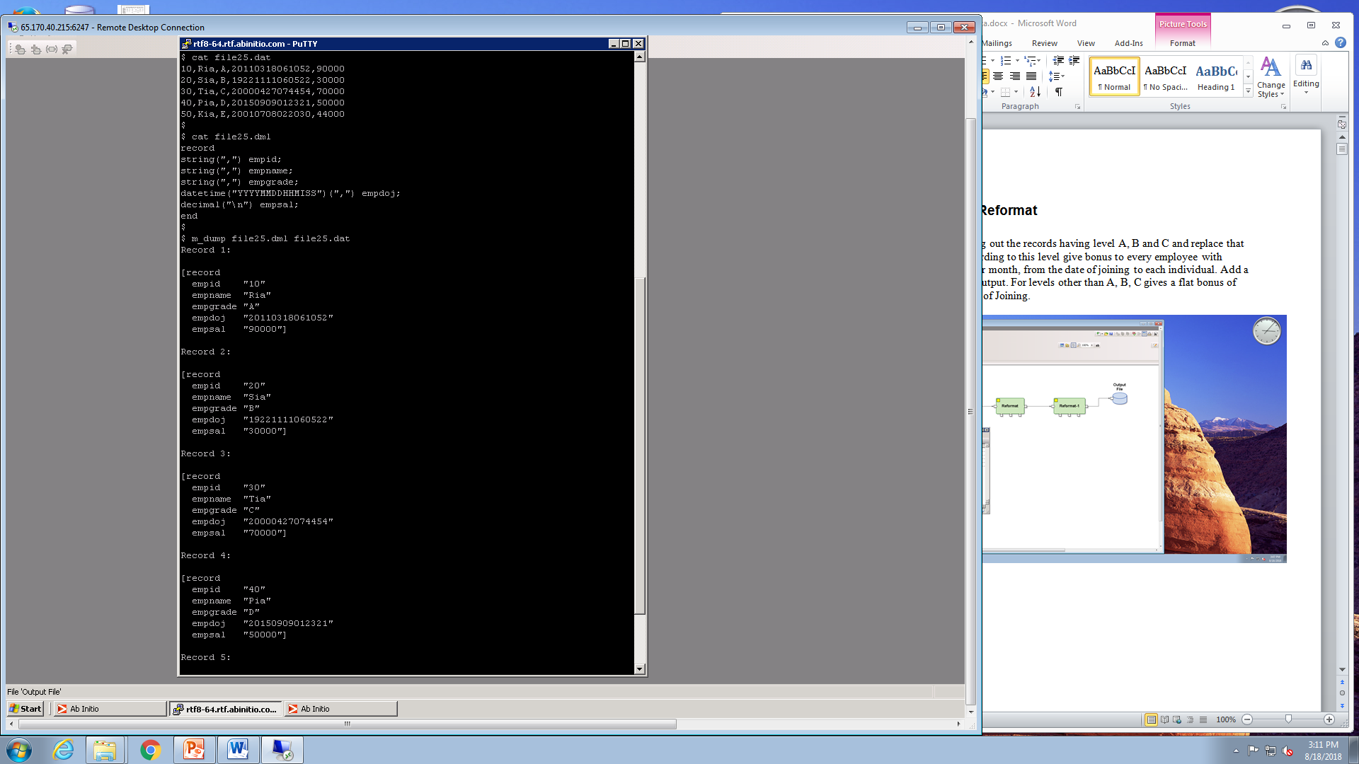

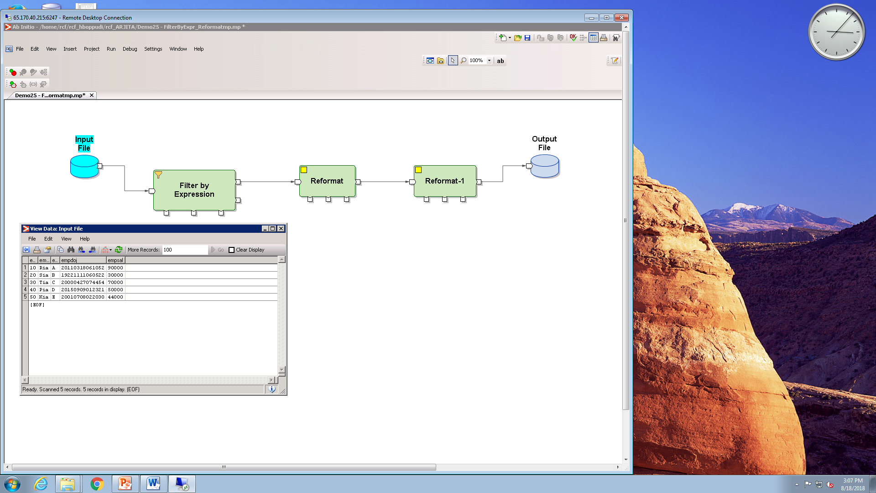

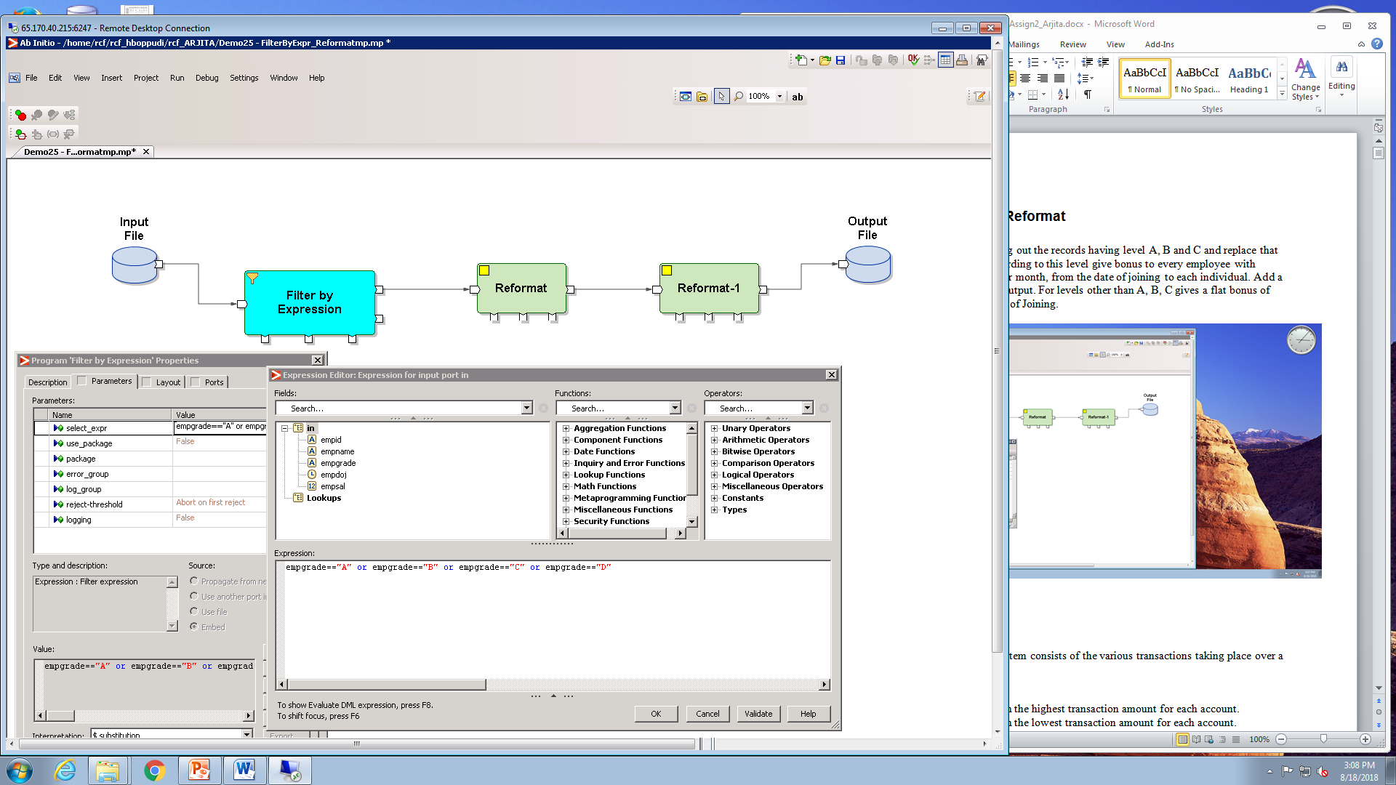

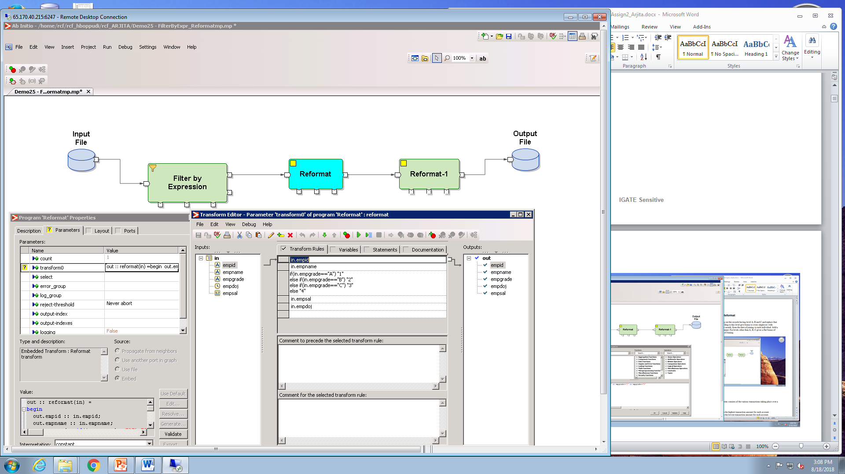

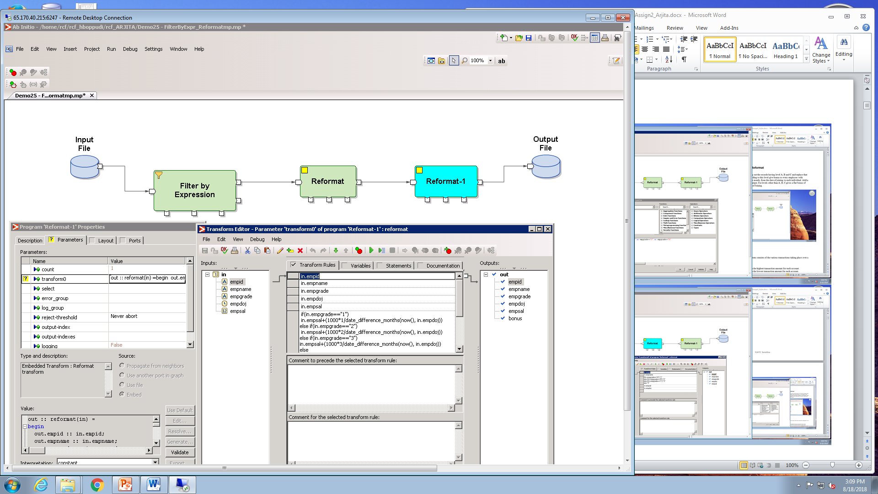

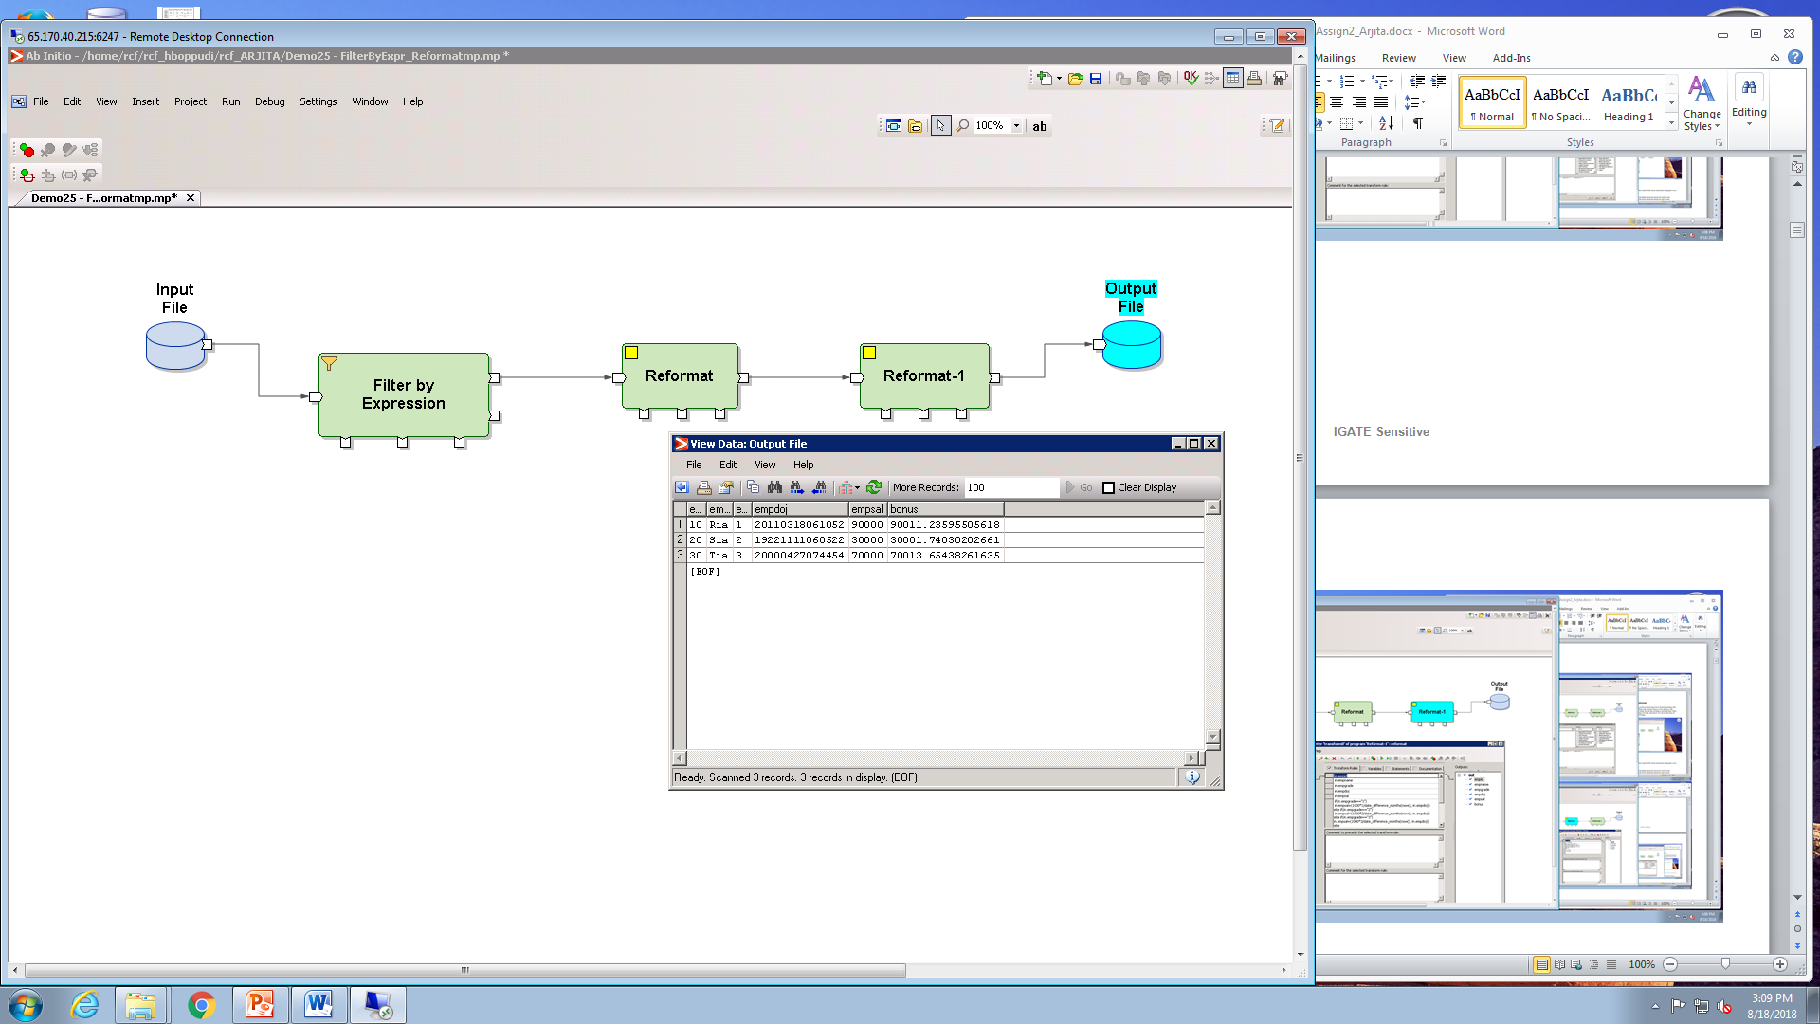

1. **Sort & Dedup**

A feed file from a banking system consists of the various transactions taking place over a period of time.

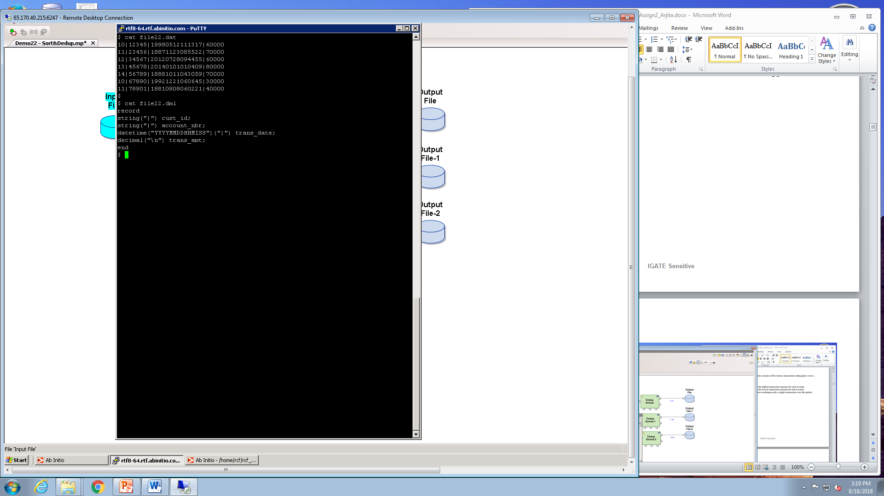

Data imn input file:

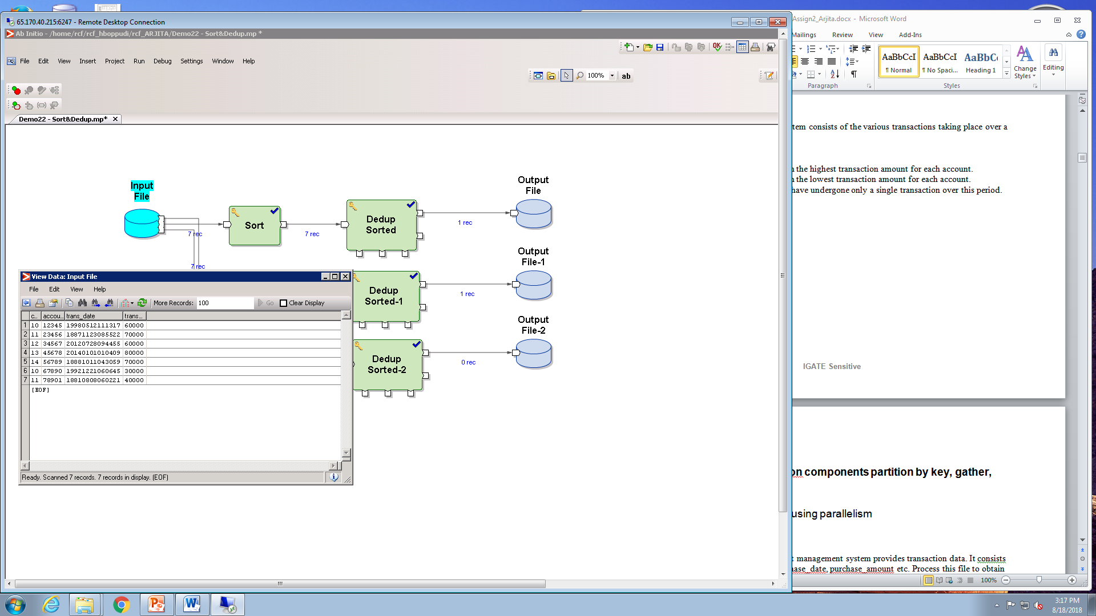

Sorting the data with trans_amt column:

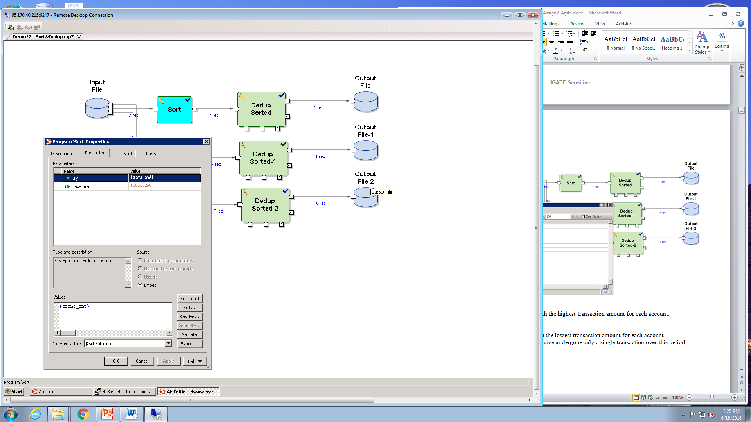

Process this file as below.

1. Obtain the transactions with the highest transaction amount for each account.

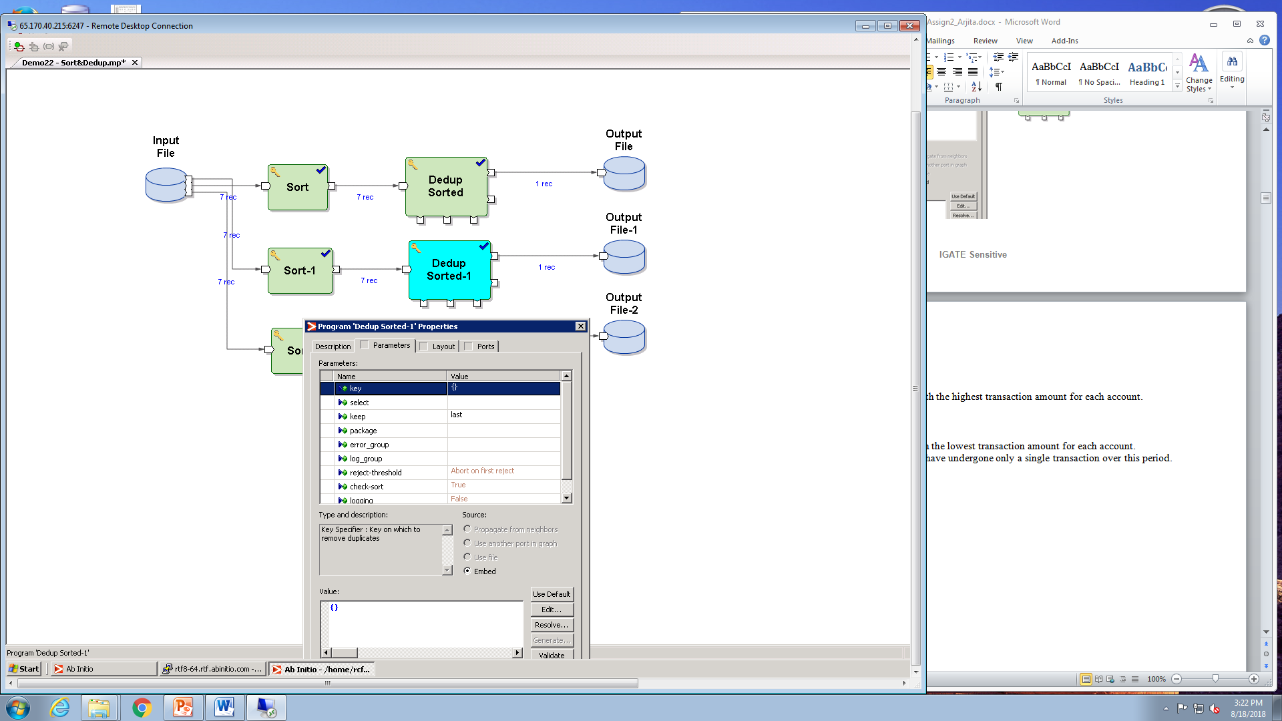

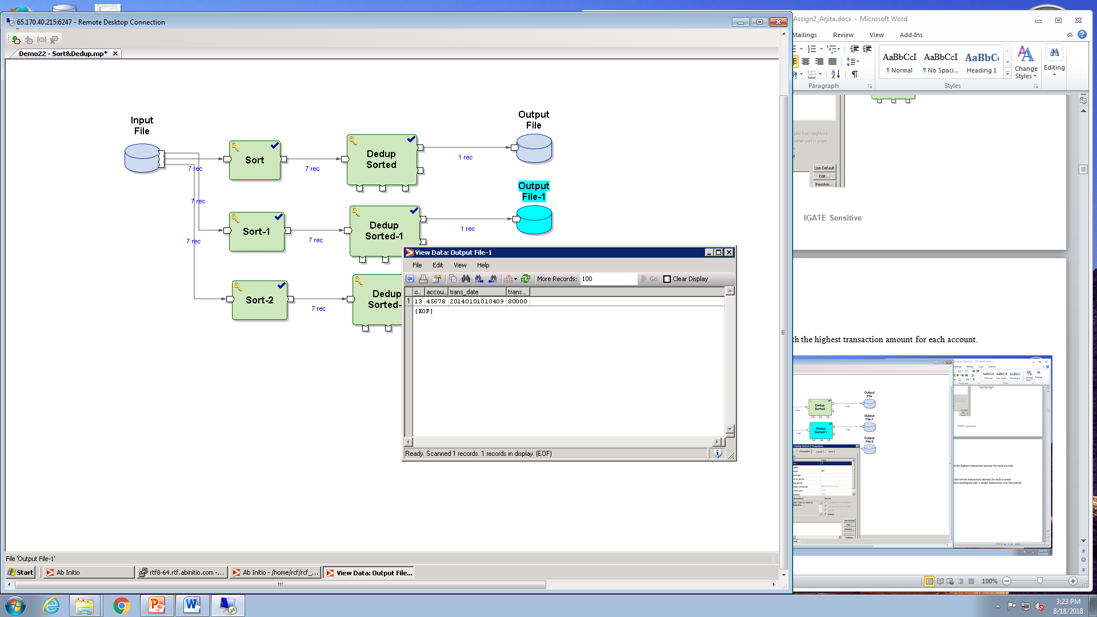

1. Obtain the transactions with the lowest transaction amount for each account.

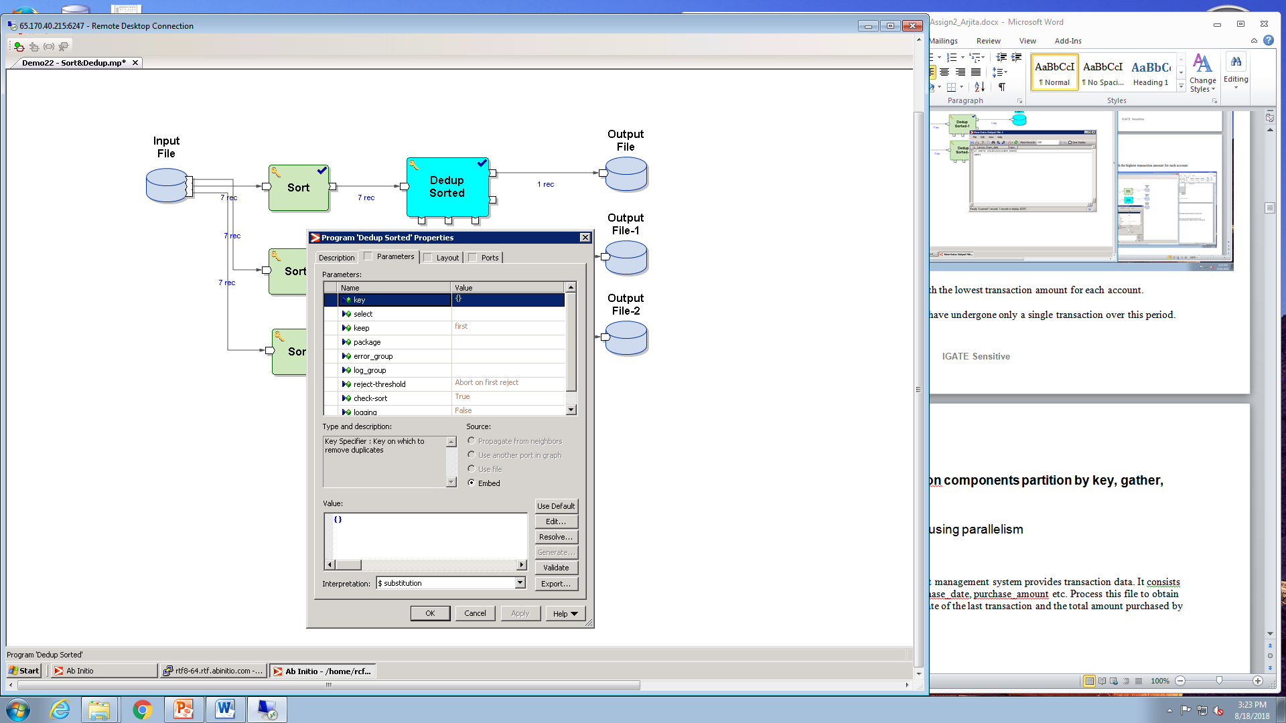

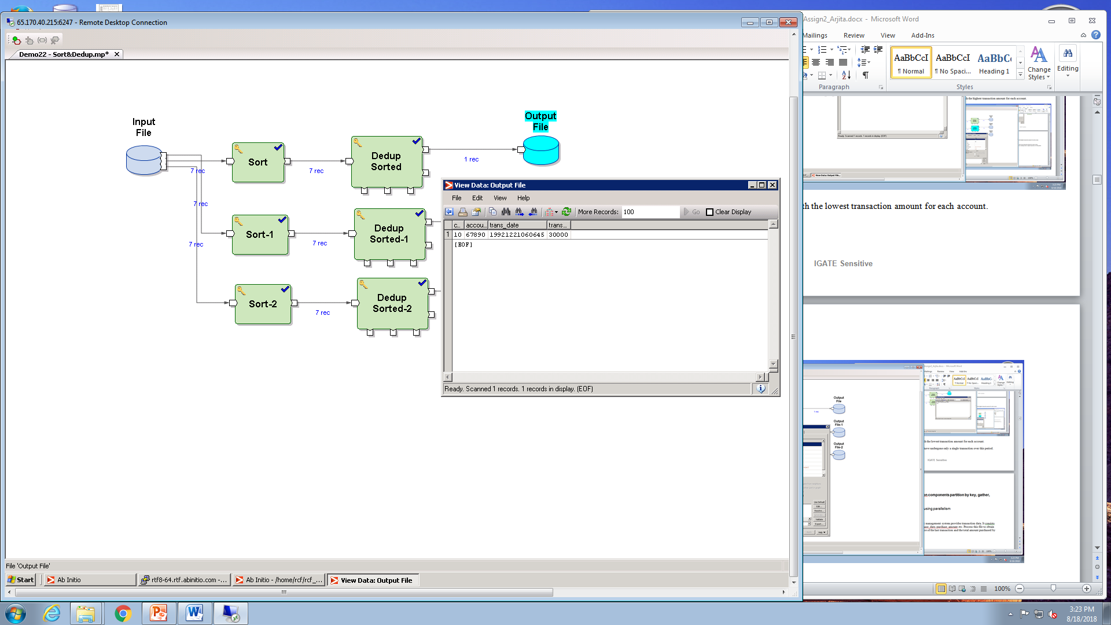

1. Obtain the accounts which have undergone only a single transaction over this period.

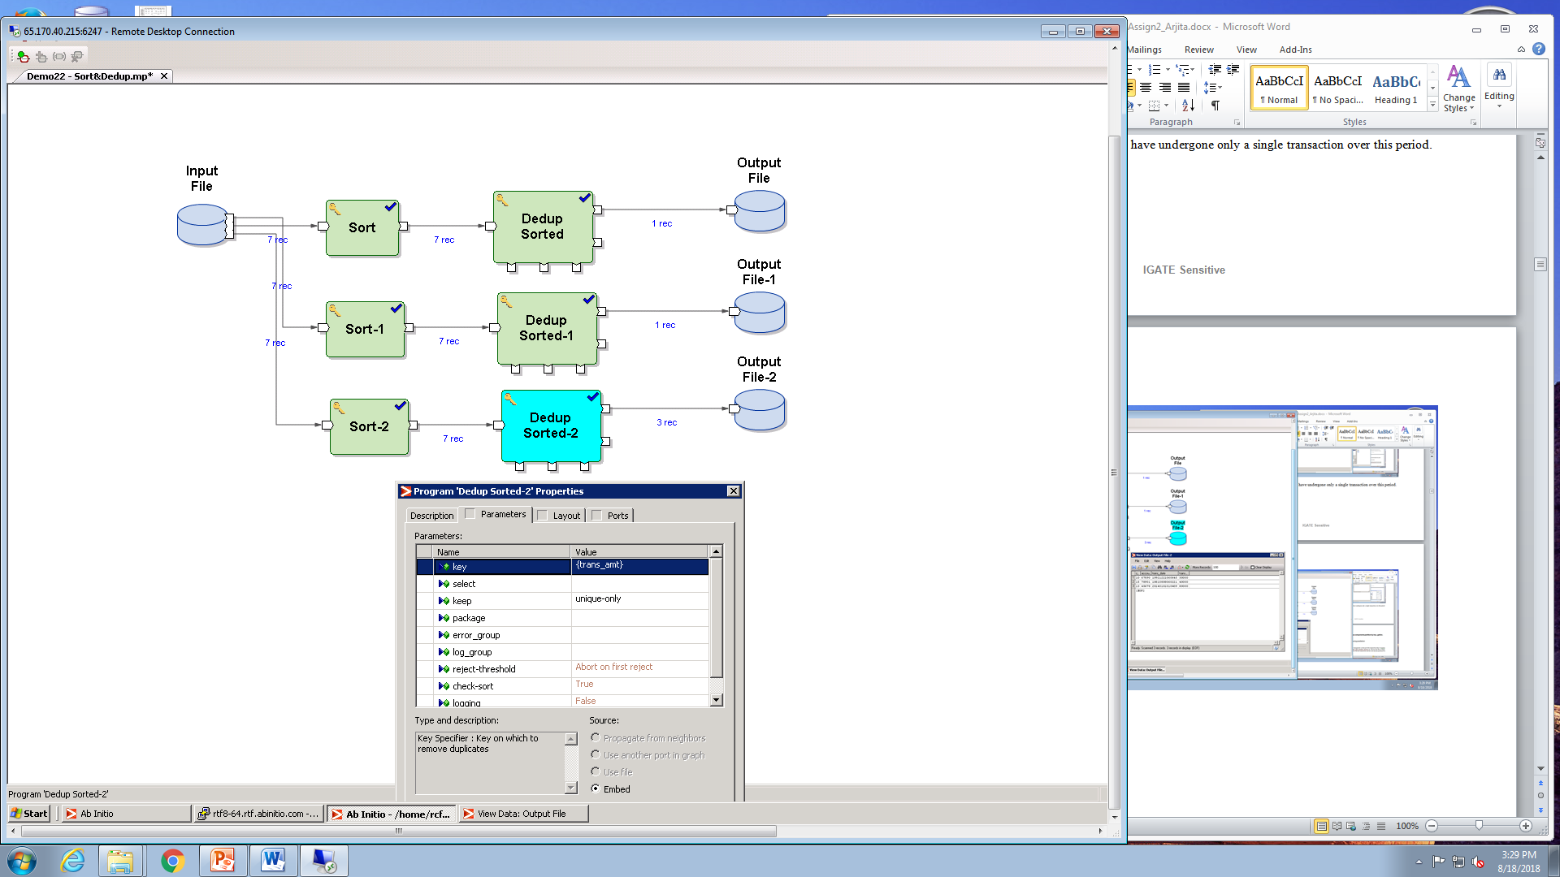

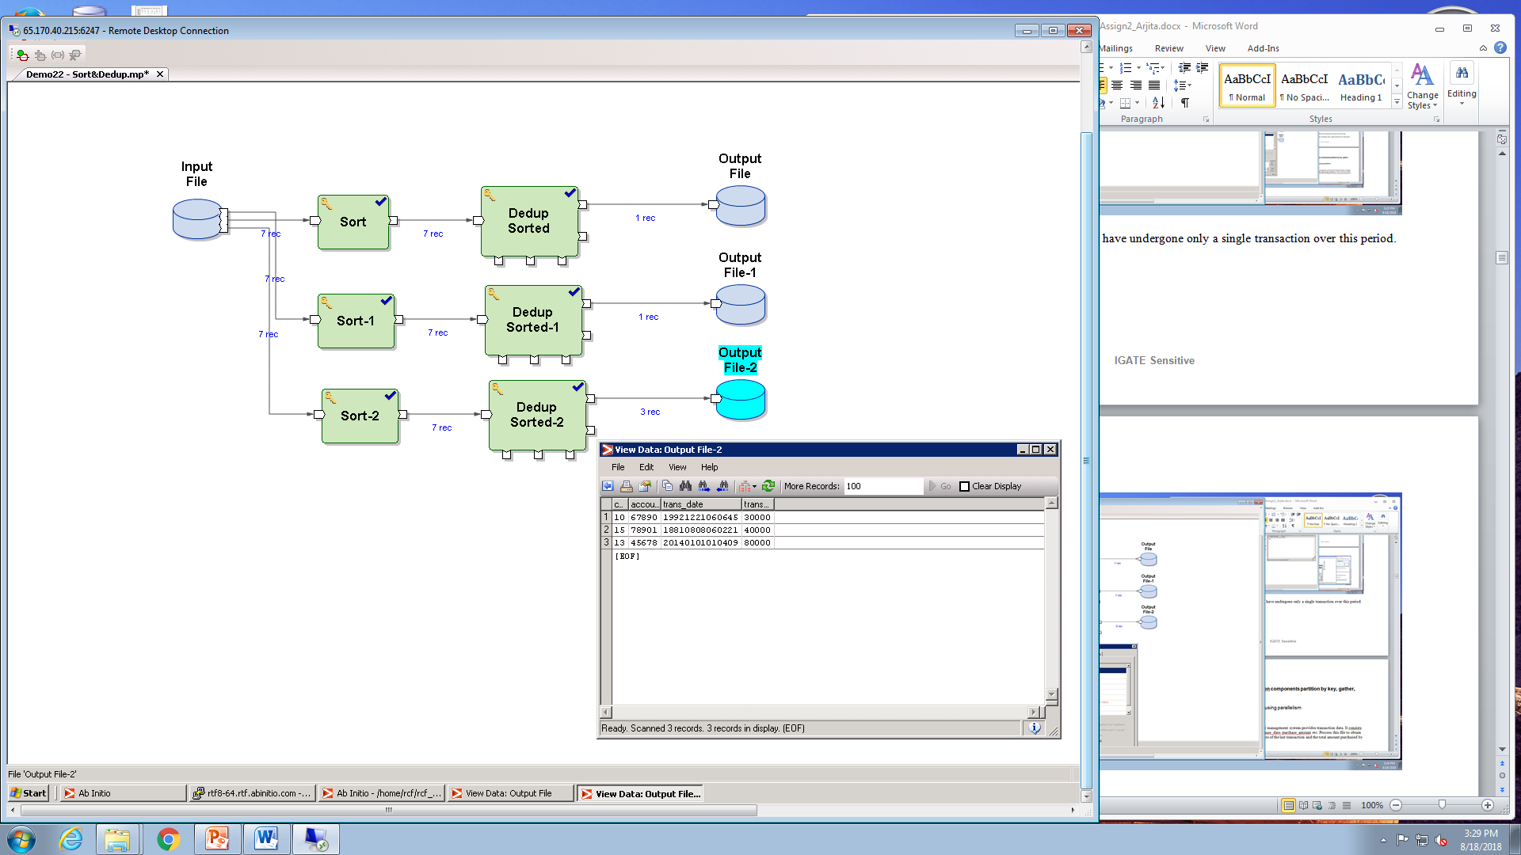

1. **Rollup**

A feed file from a supermarket management system provides transaction data. It consists details like customer_id, purchase_date, purchase_amount etc. Process this file to obtain the date of first transaction, date of the last transaction and the total amount purchased by each customer.

References

1) Input file dml

2) Output file dml

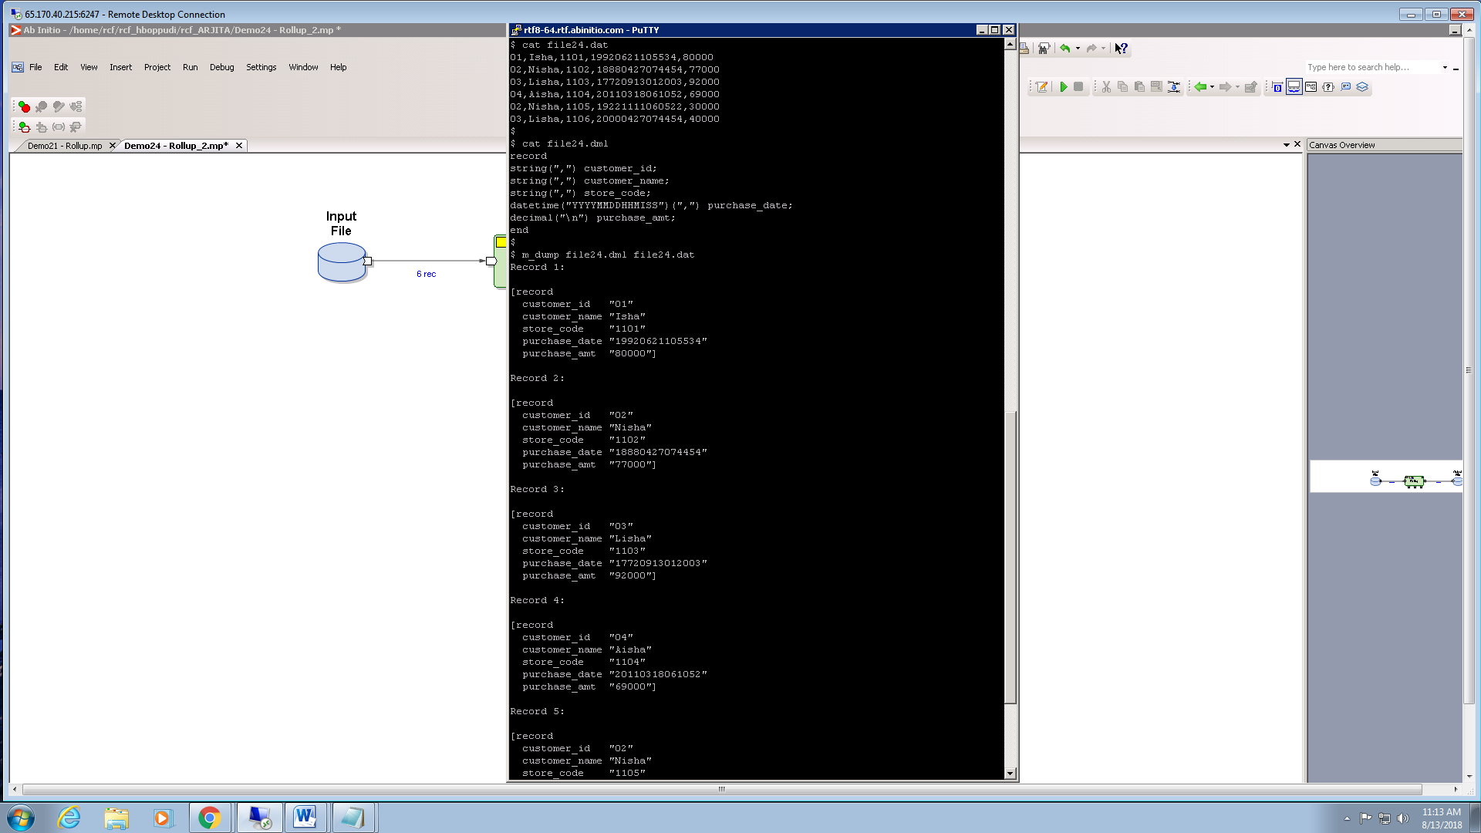

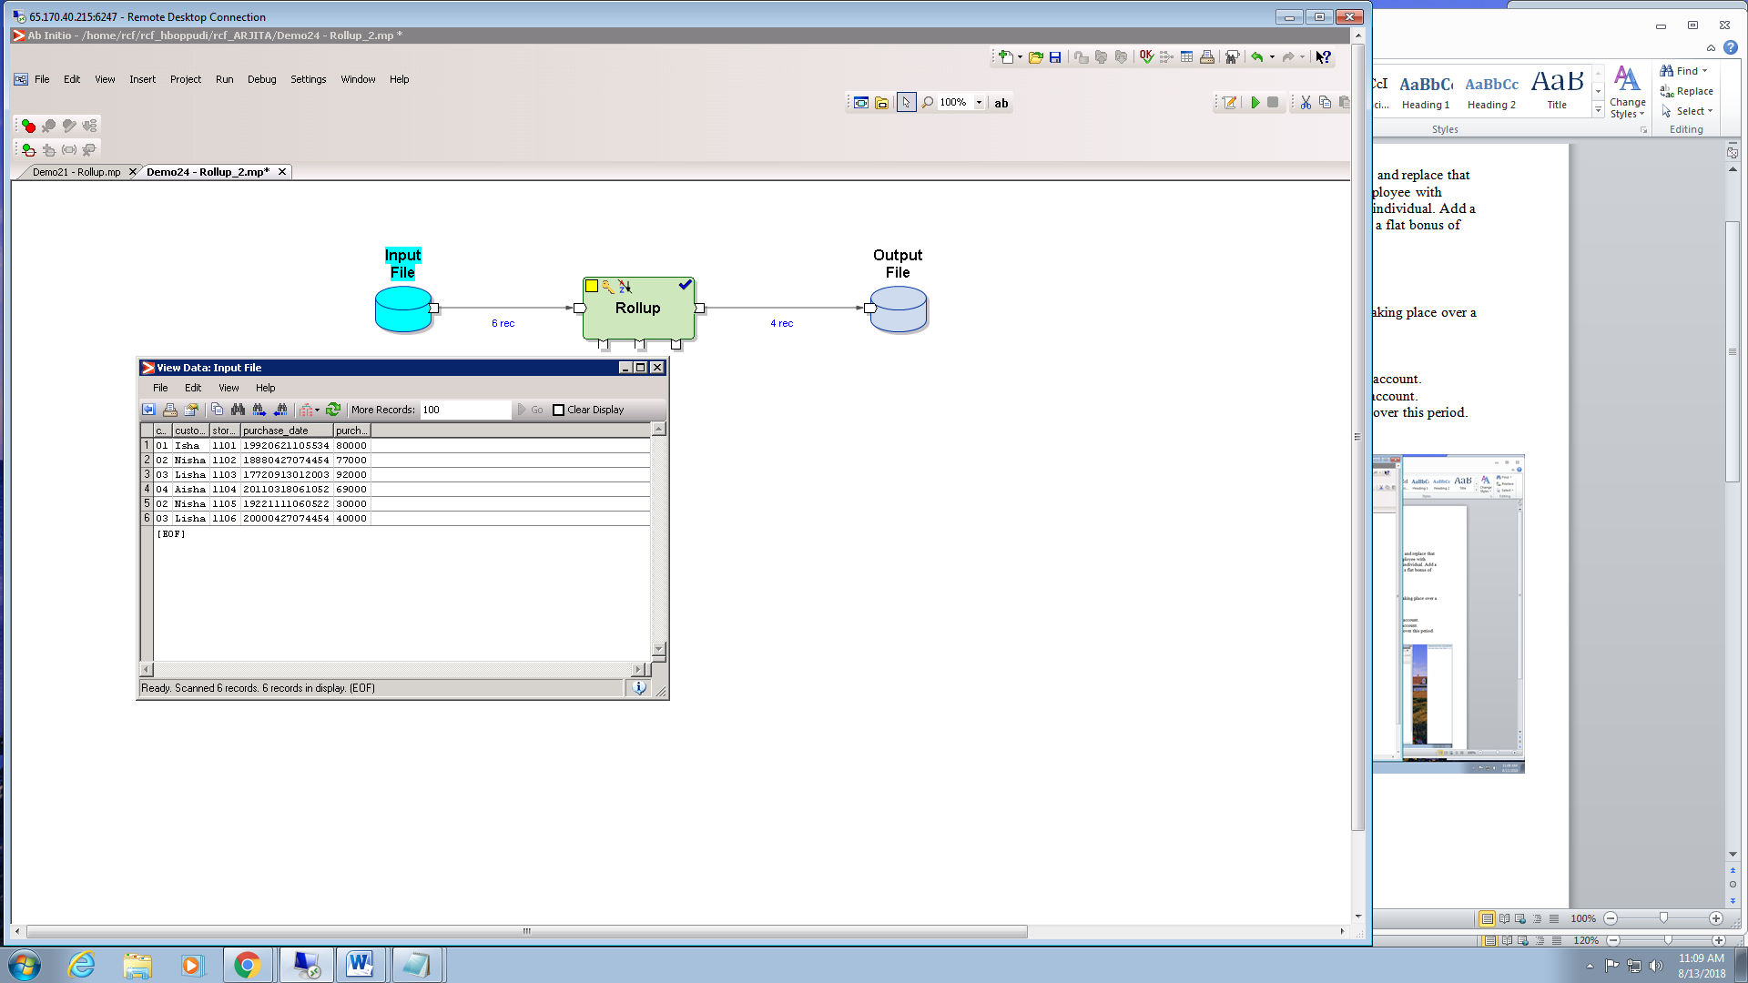

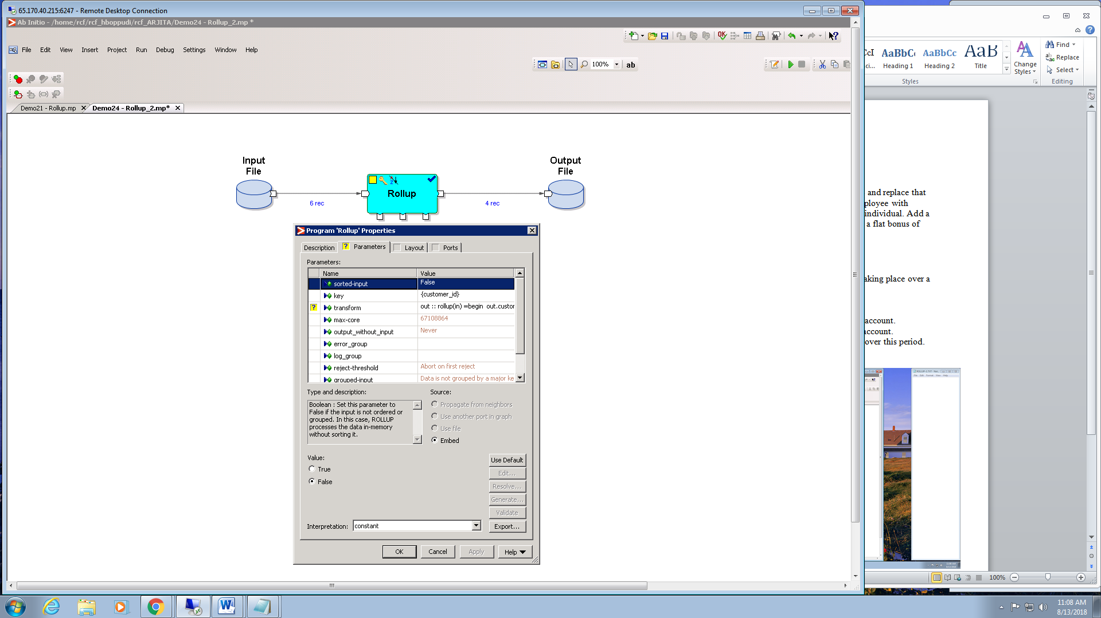

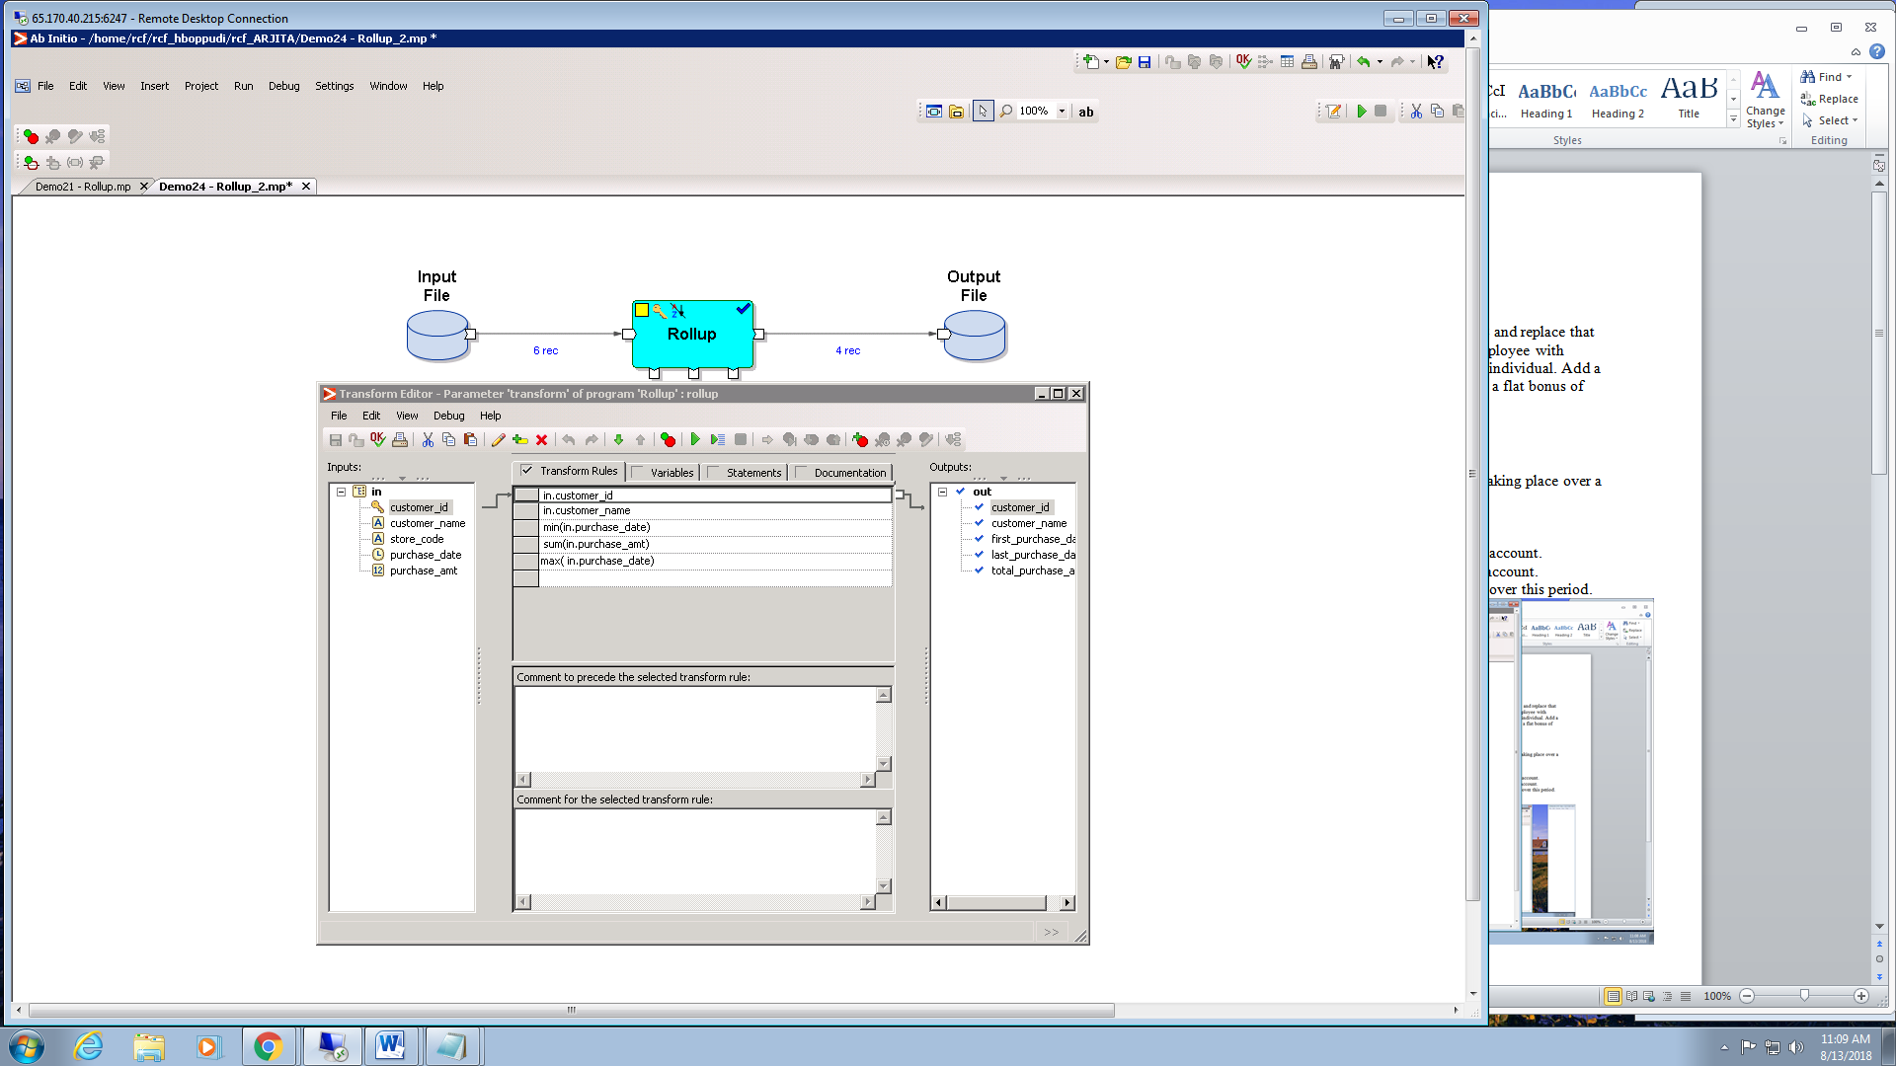

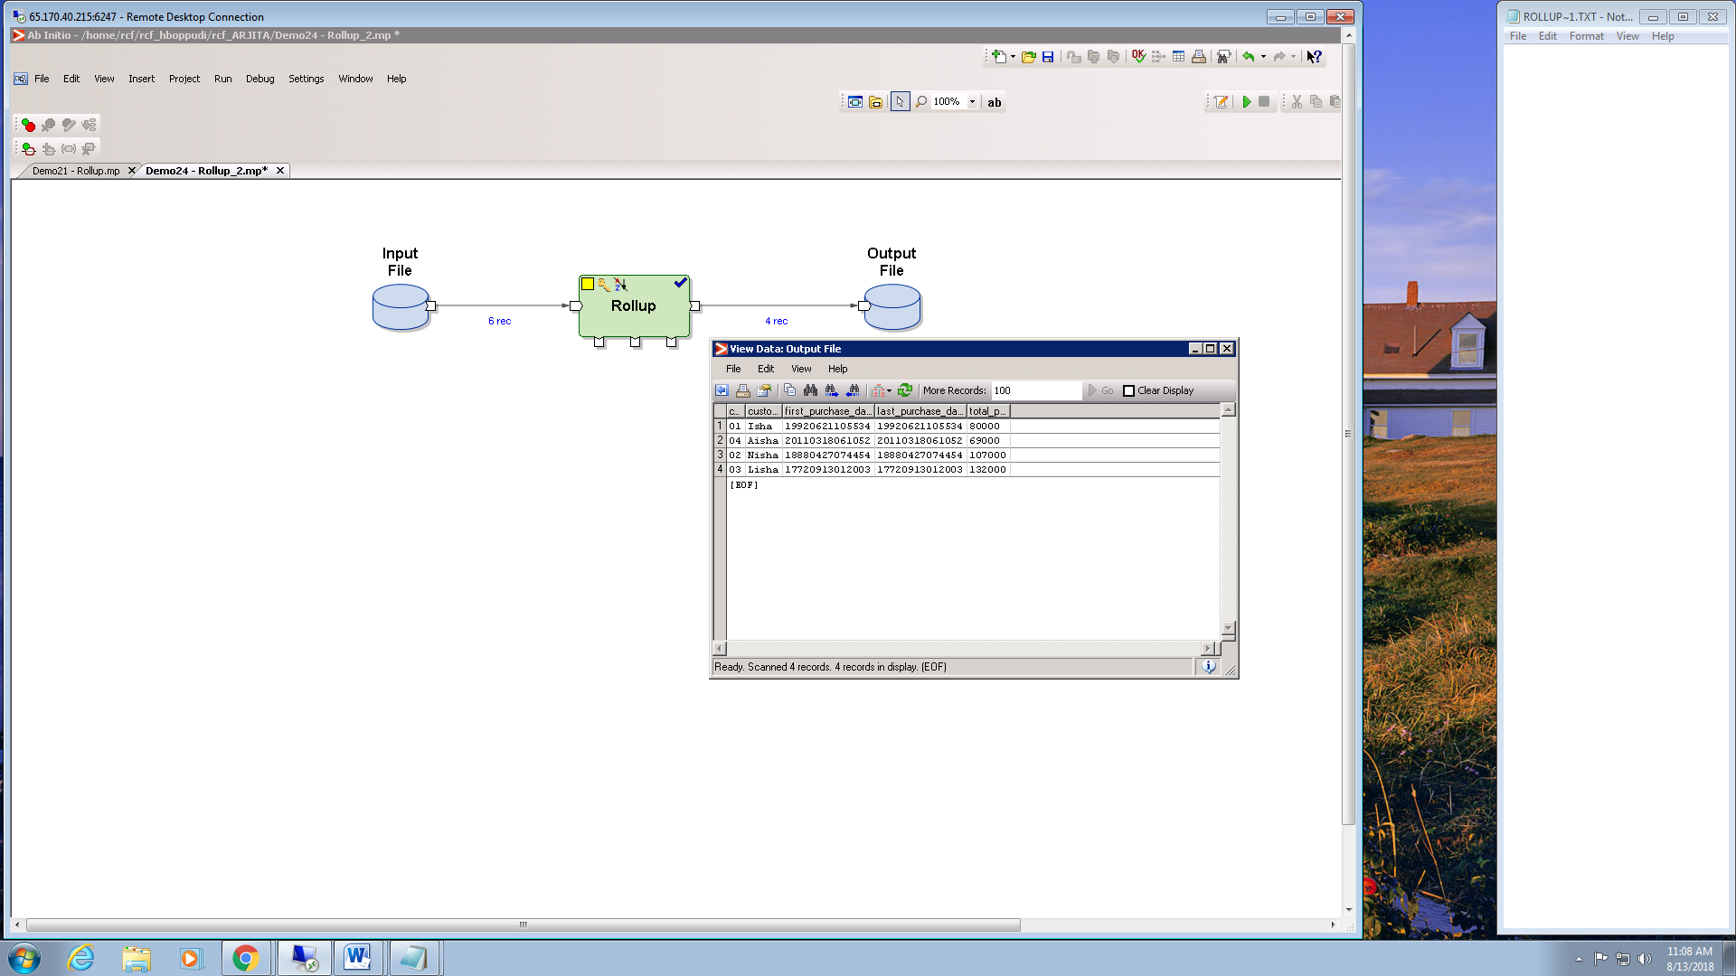

1. **Scan**

A feed file consists of transaction data from a credit card system. Details like account_nbr, transaction_date & time and the transaction amount are present. However the available credit limit after each transaction is not available. Assume that before the first transaction for each account the available credit limit is Rs 100000. Use the scan component to provide details about the available credit limit after each transaction.

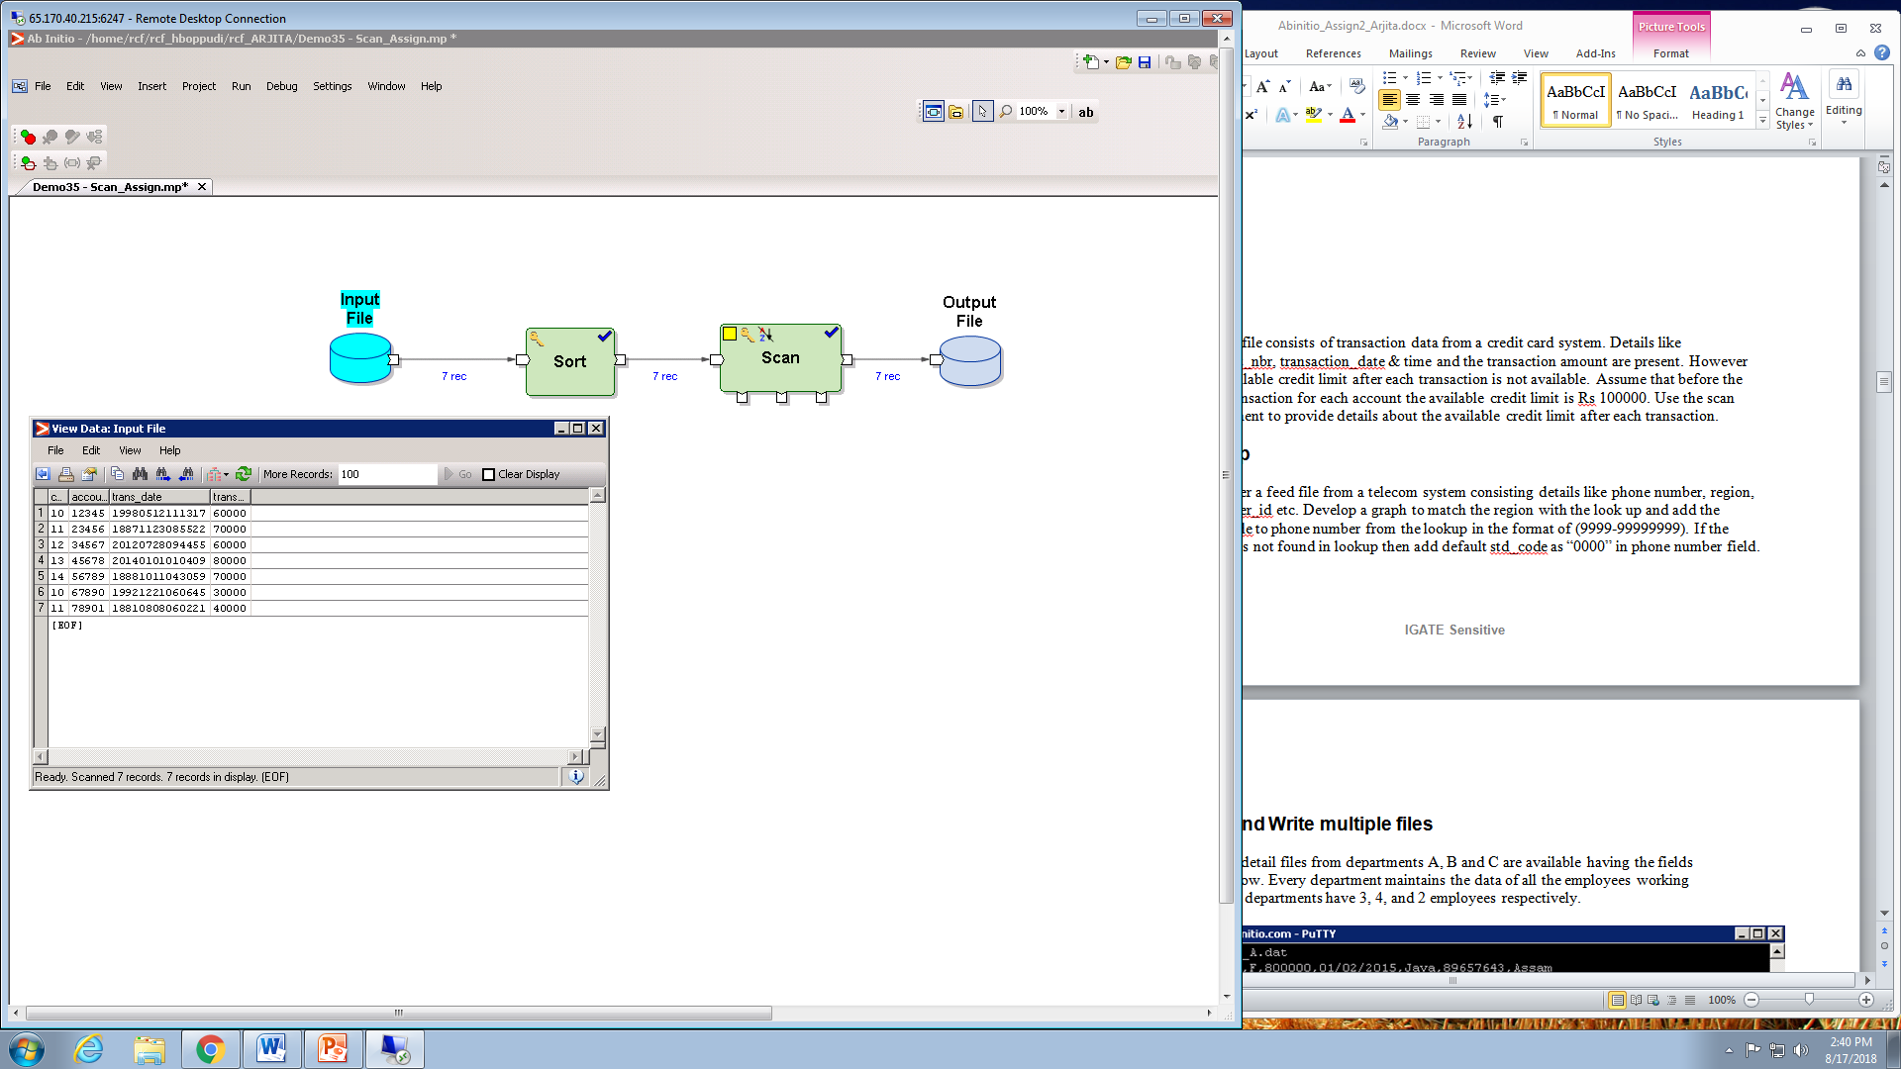

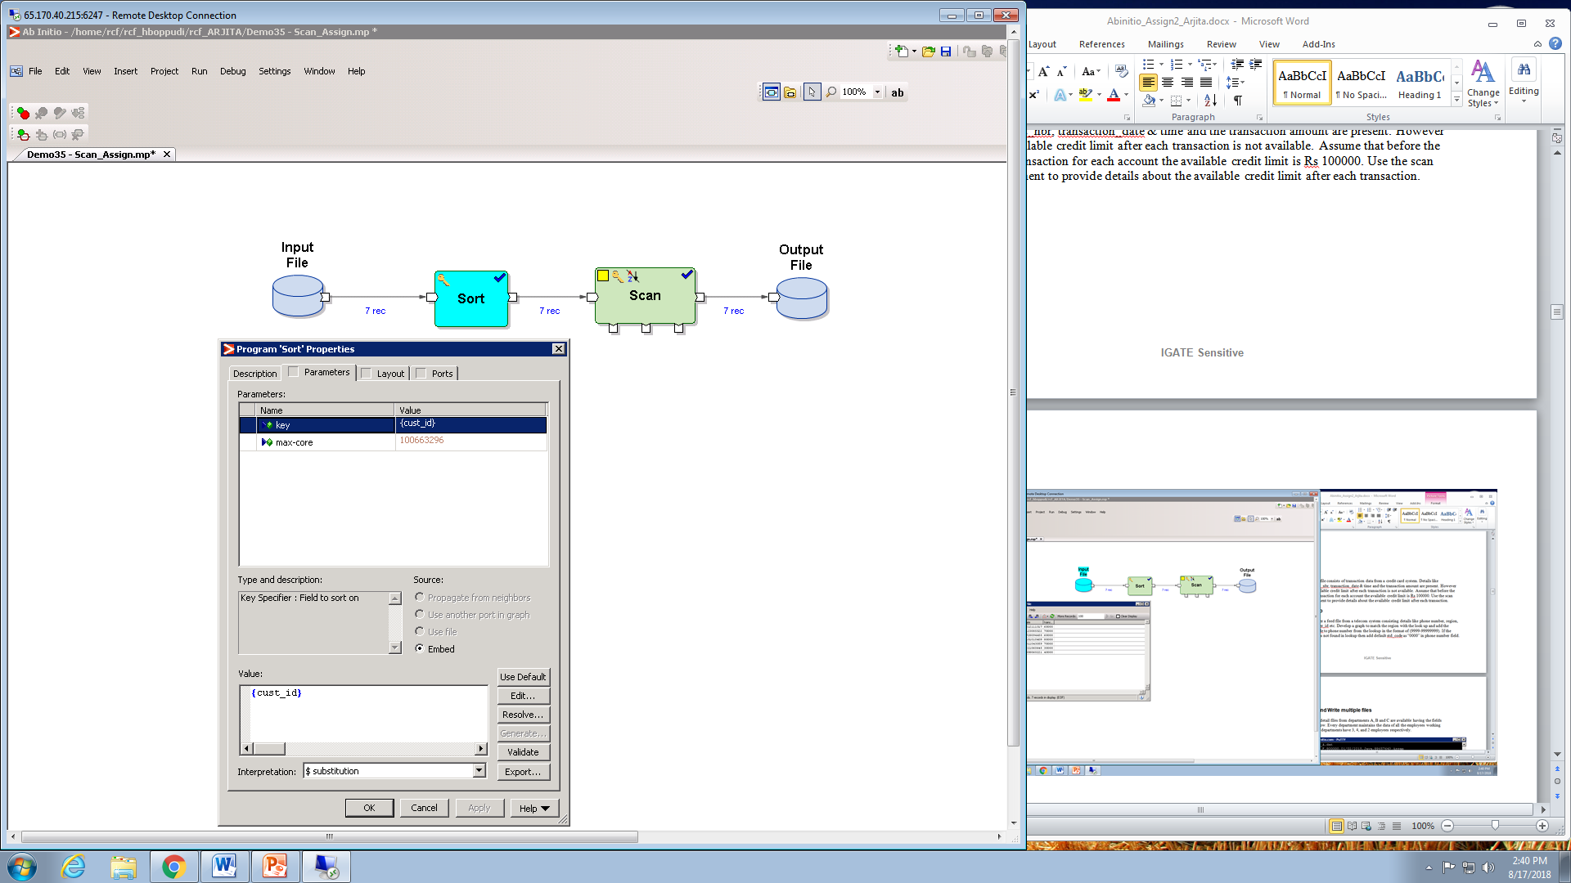

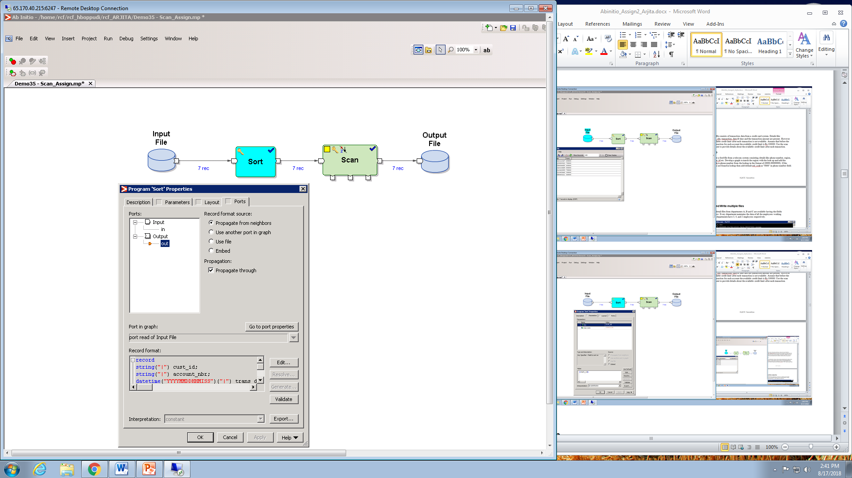

\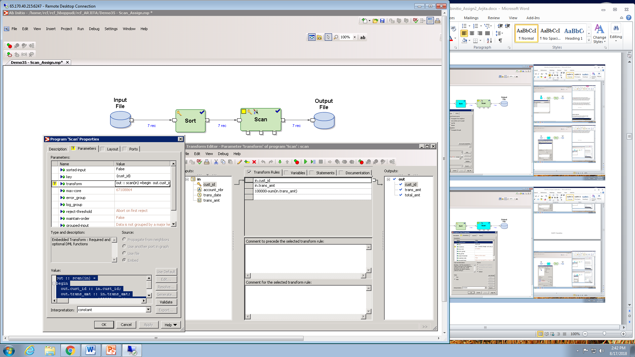

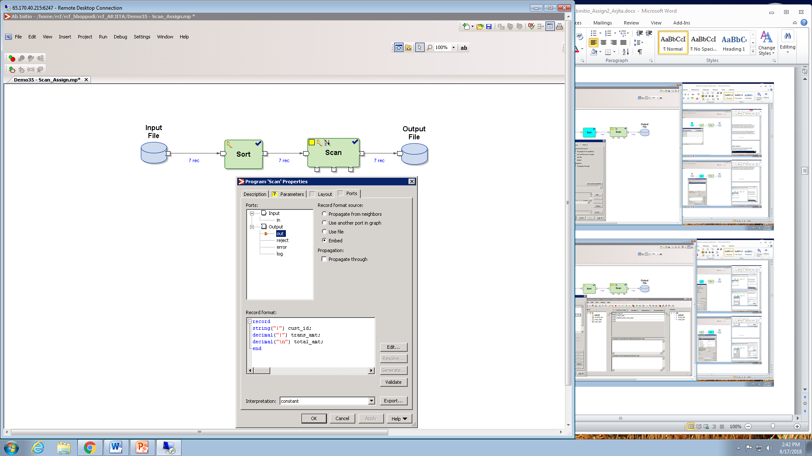

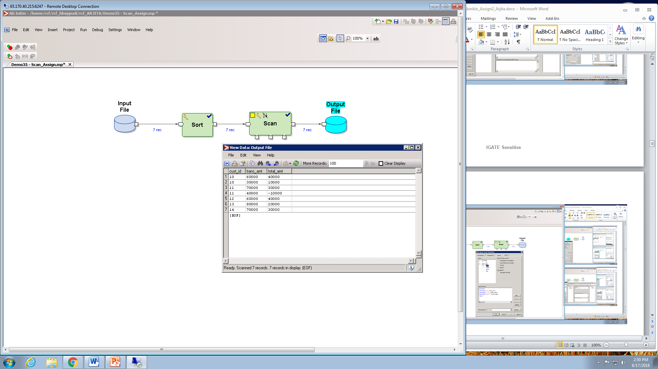

1. **Lookup**

Consider a feed file from a telecom system consisting details like phone number, region, customer_id etc. Develop a graph to match the region with the look up and add the std_code to phone number from the lookup in the format of (9999-99999999). If the region is not found in lookup then add default std_code as “0000” in phone number field.

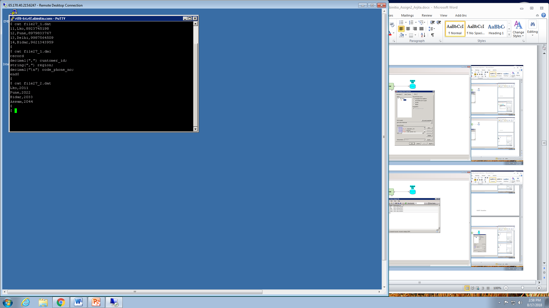

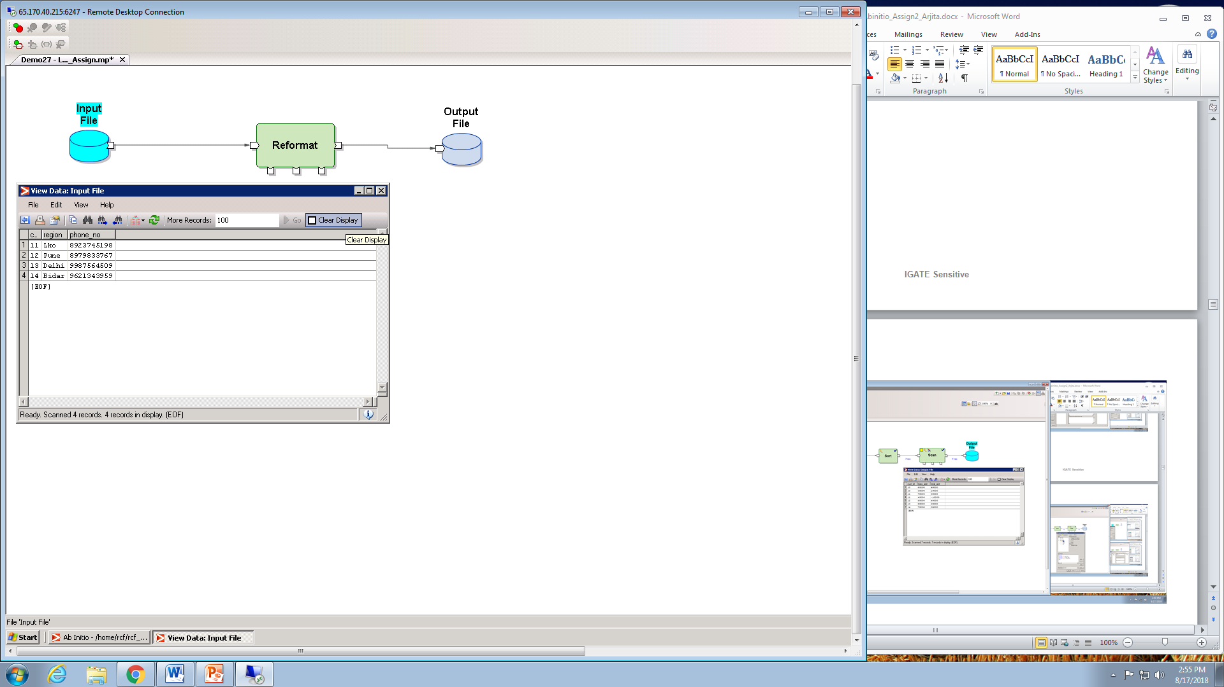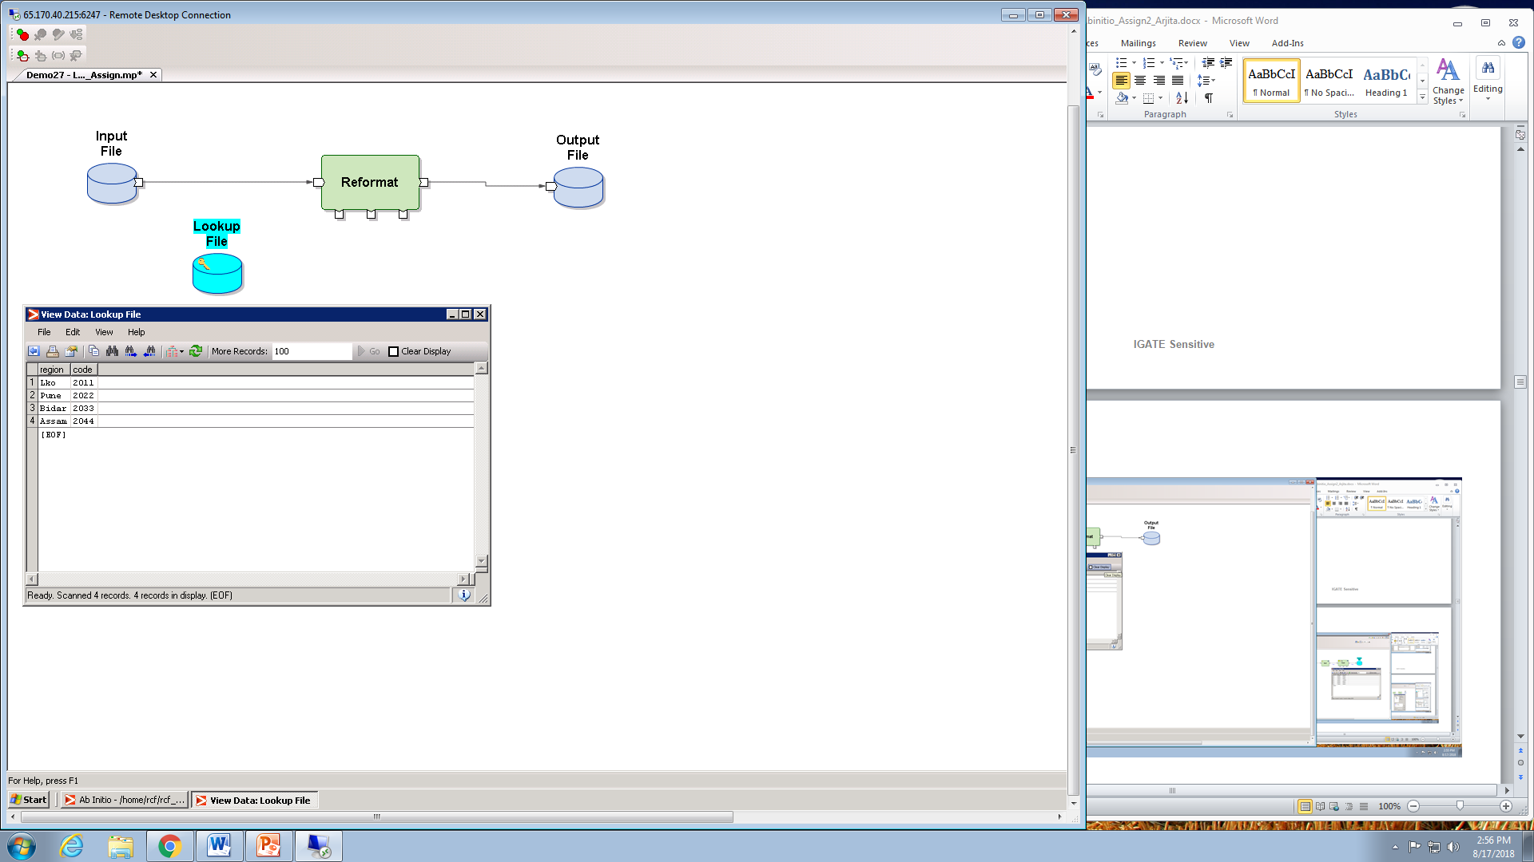

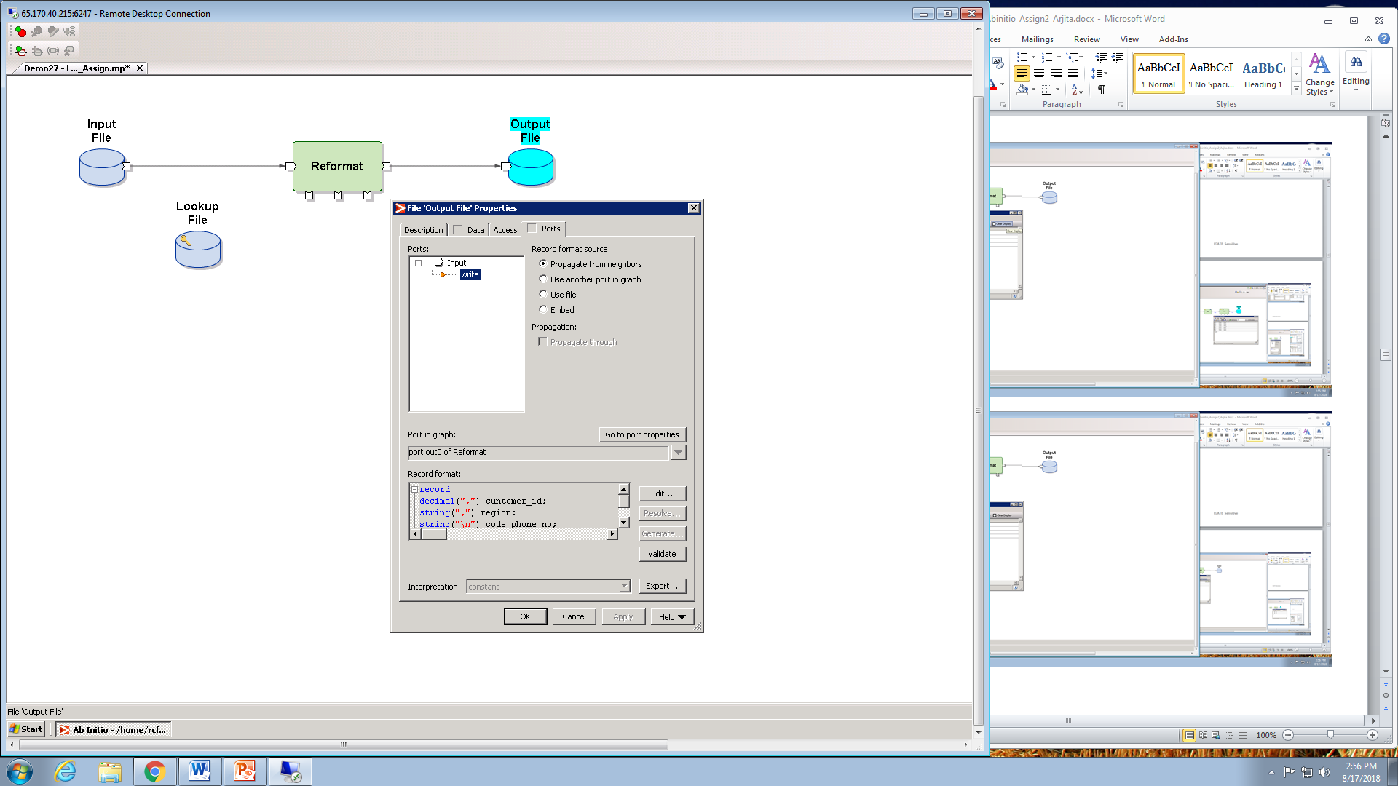

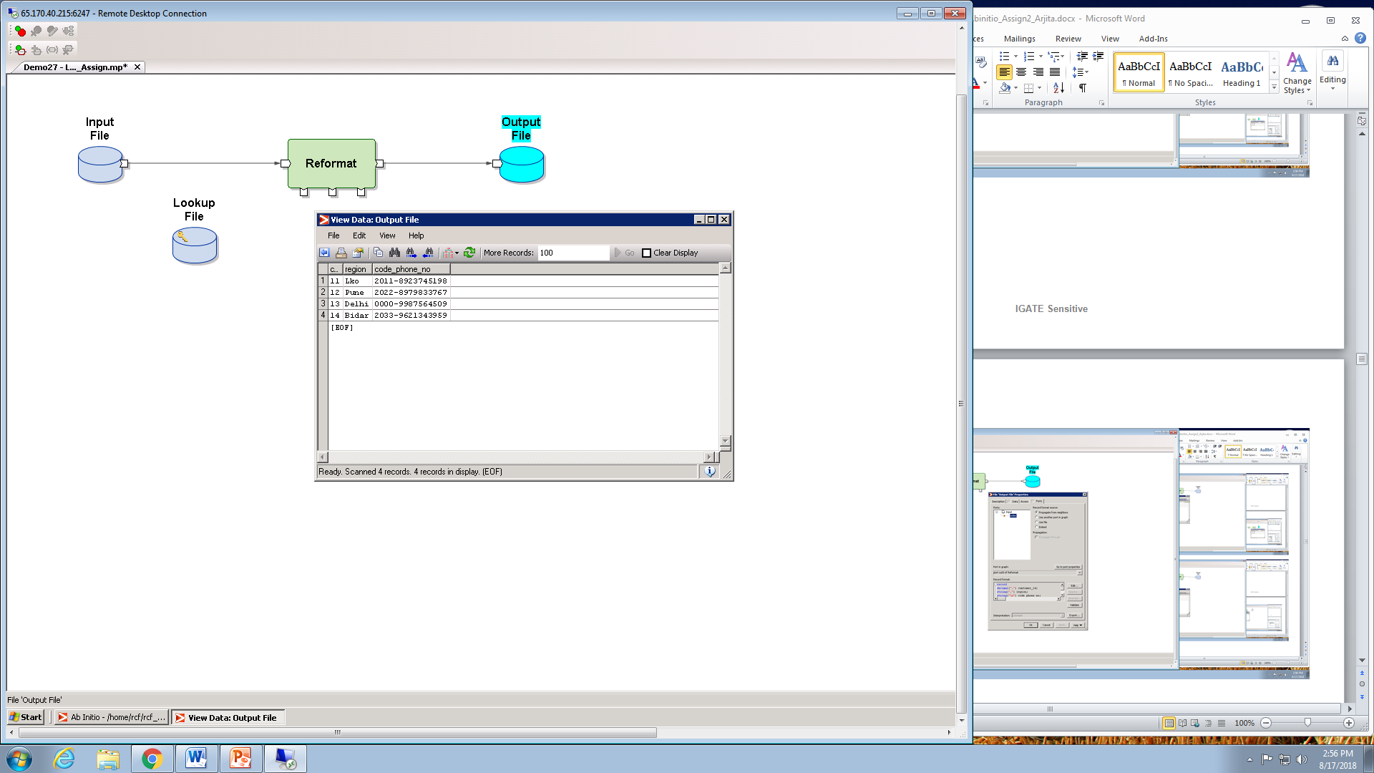

1. **Read and Write multiple files**

The employee detail files from departments A, B and C are available having the fields

mentioned below. Every department maintains the data of all the employees working

in it only. The departments have 3, 4, and 2 employees respectively.

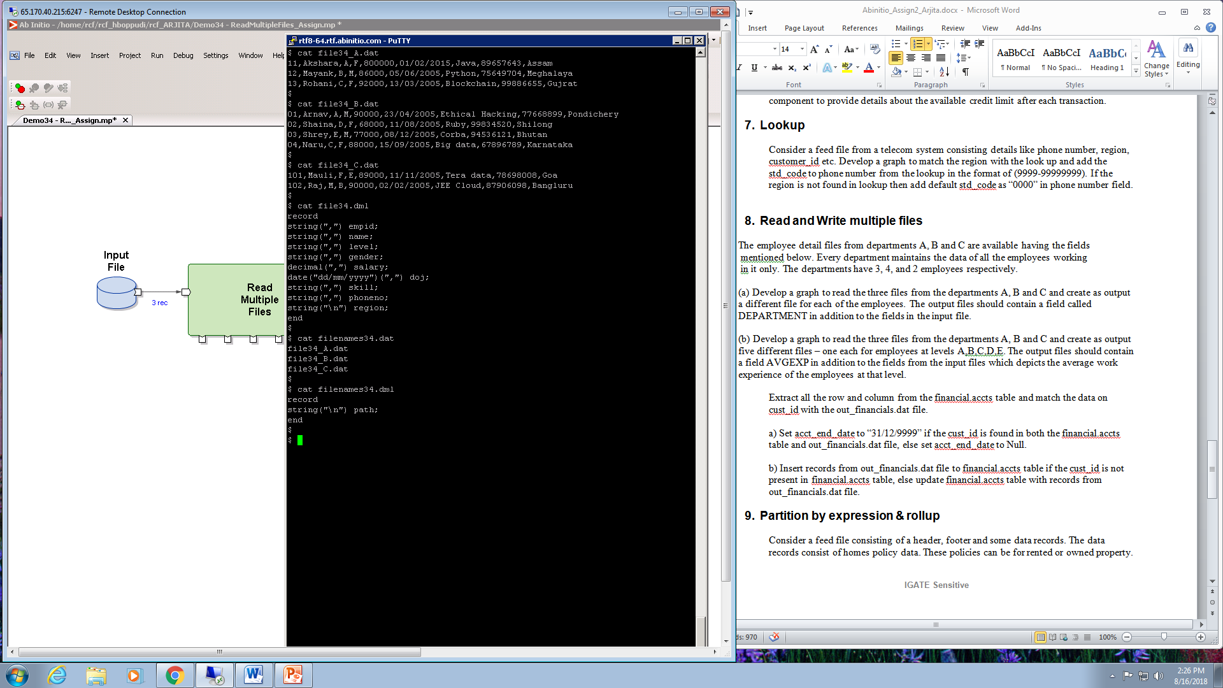

1. Develop a graph to read the three files from the departments A, B and C and create as output a different file for each of the employees. The output files should contain a field called DEPARTMENT in addition to the fields in the input file.

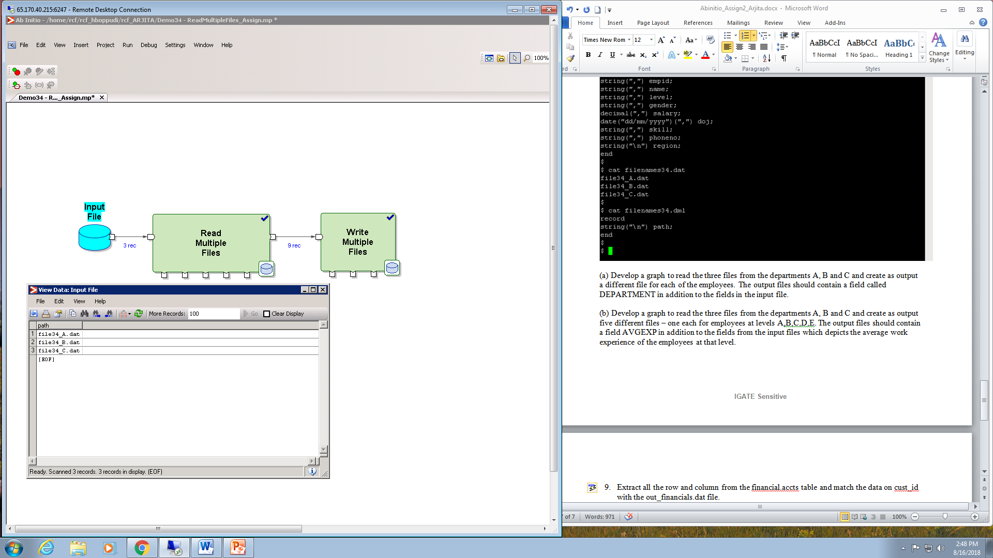

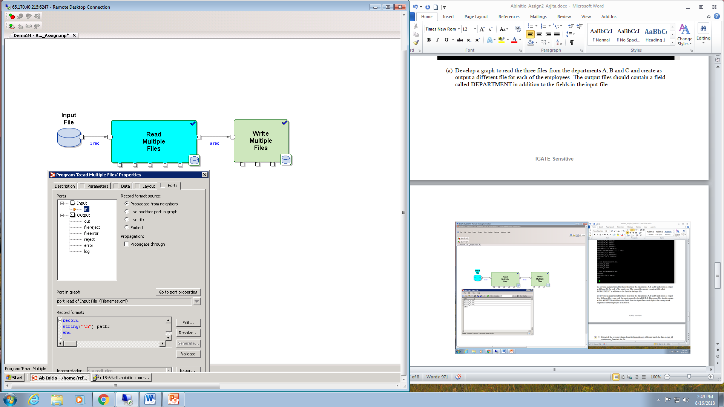

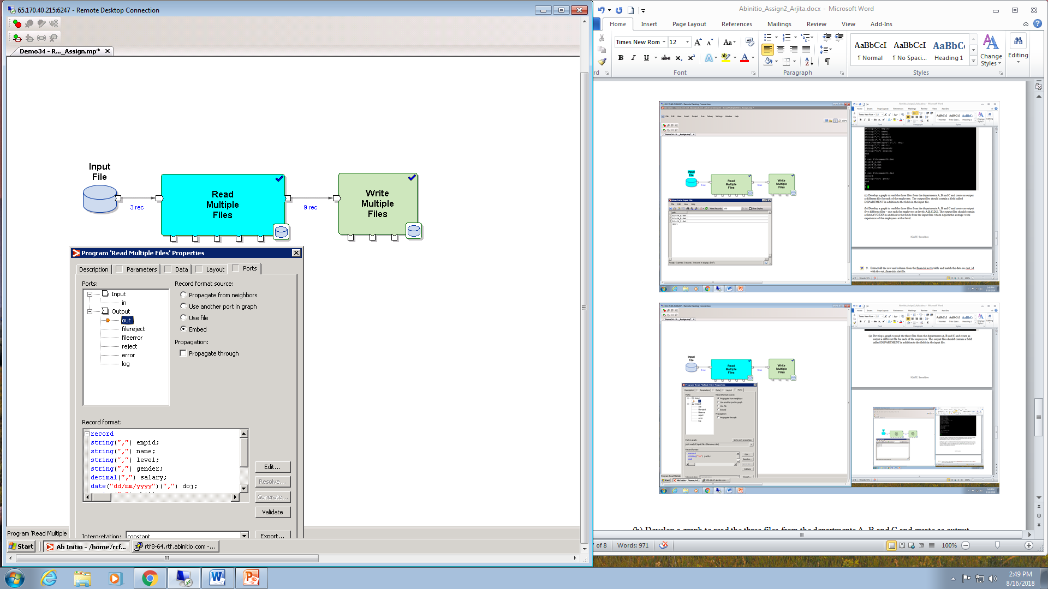

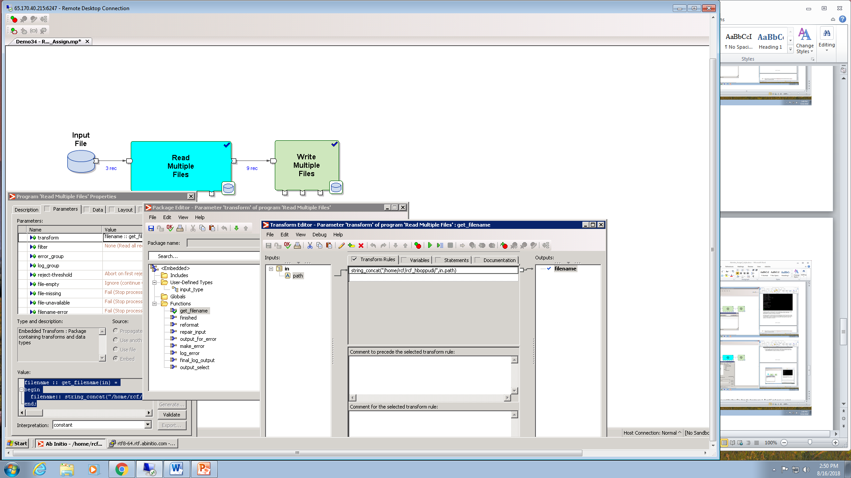

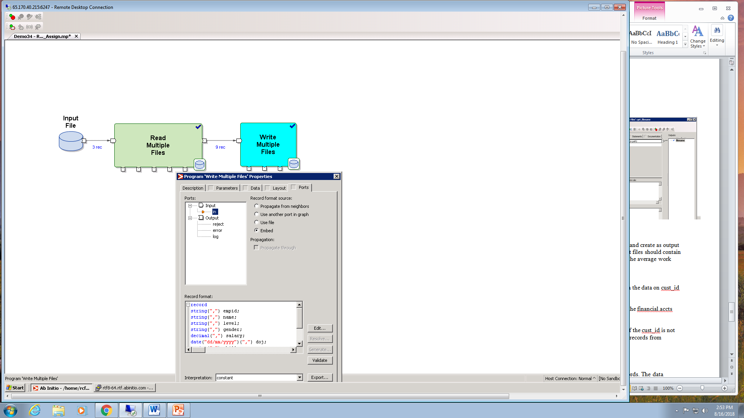

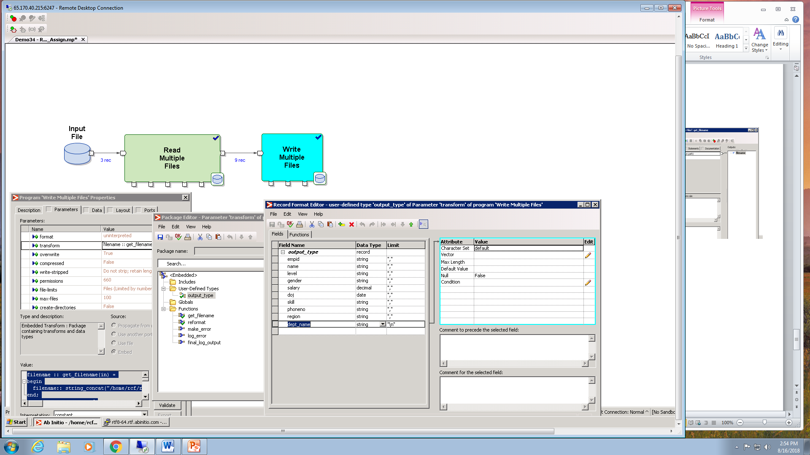

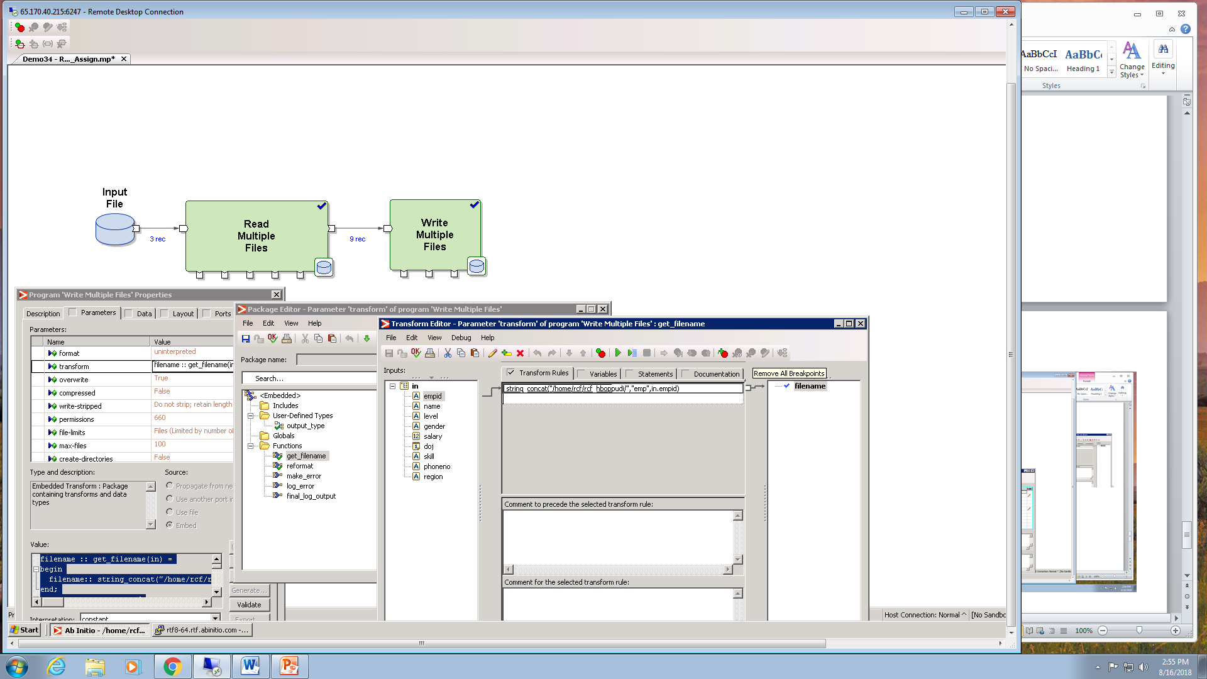

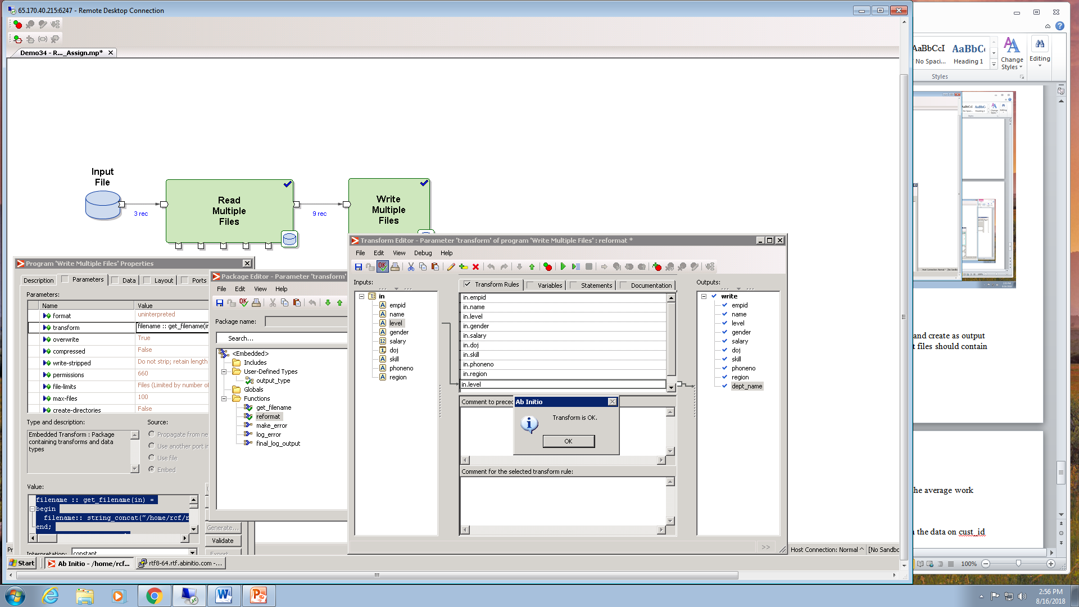

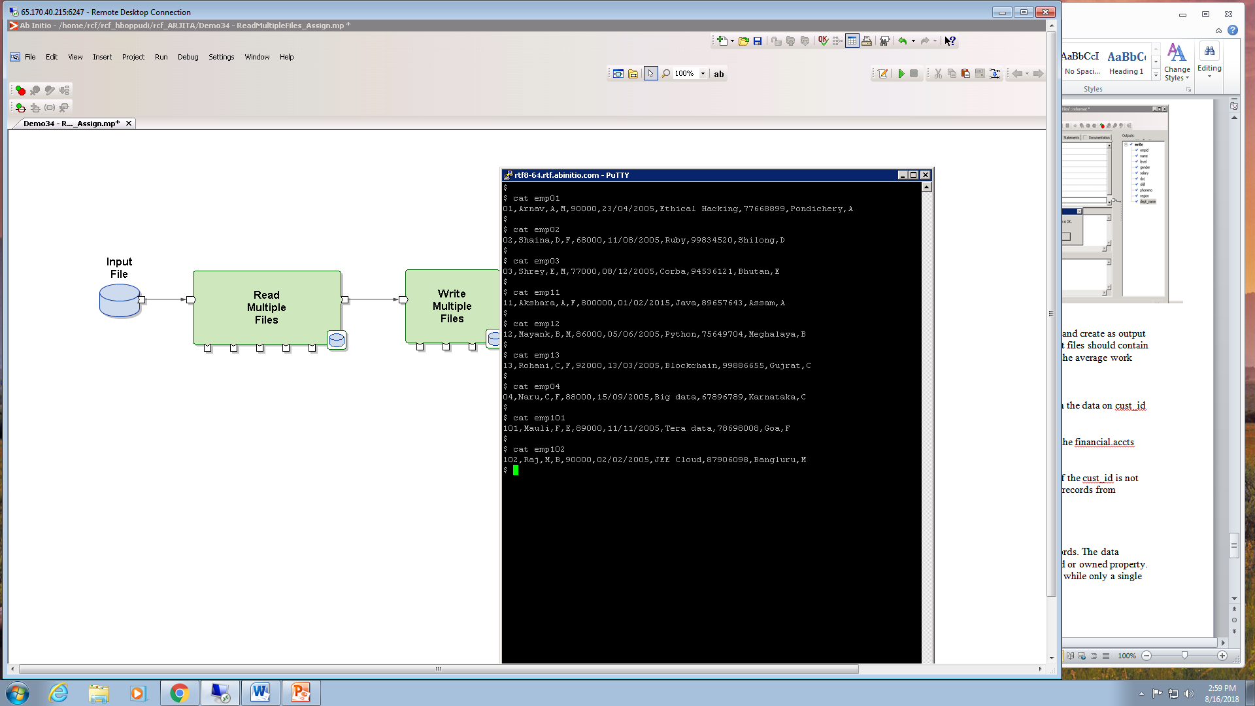

(b) Develop a graph to read the three files from the departments A, B and C and create as output five different files – one each for employees at levels A,B,C,D,E. The output files should contain a field AVGEXP in addition to the fields from the input files which depicts the average work experience of the employees at that level.







